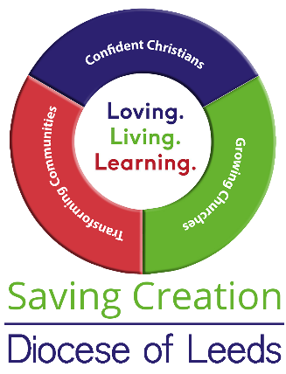
Lament for the Degradation of the Environment, Loss of Diversity of Species and Waste of Precious Resources
Resources for sermon or reflection

The Book of Lamentations in the Septuagint is placed after and alongside the Book of the prophet Jeremiah, well known for his laments. In the Hebrew Bible apparently, Lamentations can be found in the Writings, among the Five Scrolls, and witnesses to the destruction of the First and Second Temples in Jerusalem. If we read the Psalms, we find that ‘By the waters of Babylon’ the exiles did not merely sit and merely weep when they remembered Zion and the Temple, they planned and prepared for a new future. Jesus too wept for Jerusalem as he foresaw its destruction.

Unlike our Mediterranean cousins, mourning and lament are not intrinsically part of a British culture, where the ‘stiff upper lip’ and hidden emotion are still seen as appropriate behaviour, at least in public. Many of the new generations now recognise that grief in loss is ‘normal’, and lament or mourning is a healthy expression of our natural feelings.

Today, even as we plan for a greener and more sustainable future for our communities and eco systems, there is a need for lament for what we have lost in terms of the prevalence of clean fresh air, unpolluted atmospheres, clear water springs, abundant harvests, rich diversity of species, and teeming oceans. We cannot return. Enough is enough. We must live within the limits of our planetary boundaries.

Lament brings together our thoughts, helps us to reflect, and then enables us to move on:
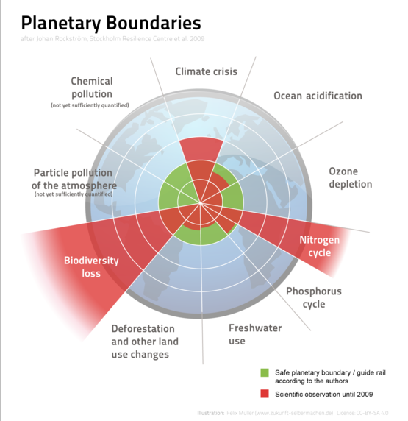
Lord, our earth is sick:
Carbon emissions are rising: the air we breathe is polluted by our busy traffic systems.
Our cities are sprawling: concrete encroaches on green pastures and public land.
The waters of our rivers and streams are polluted by industrial waste and garbage.
The seas are acidified and polluted by plastic waste.
The land is poisoned by excessive chemical fertilizers and additives.
The forests are stripped by bare by excessive logging.
Deserts are without rain and drought prevails.
The rivers overflow and floods encroach and drown.
Habitats are destroyed; animal and insect species decrease.
Our food is tainted.
Disease is endemic; pandemic rife.
The security of humanity is at crisis.
We are at tipping point.
What has happened to our responsibility, our ethics, our way of life?
Do we not feel the heartbreak in the heart of things?

Author: Christine Jack. Leeds Diocesan Environment Group. Worship and Liturgy. March 2021

For further reading and documentary film coverage:

David Attenborough: A Life on Our Planet is a 2020 British documentary film narrated by David Attenborough The film acts as a "witness statement", through which Attenborough shares first-hand his concern for the current state of the planet due to humanity's impact on nature and his hopes for the future. It was released on Netflix on 4 October 2020, along with a companion book A Life on Our Planet

