Books, Ecology and New Life
By Christine Jack, Diocesan Environment and Literature Book Club Coordinator
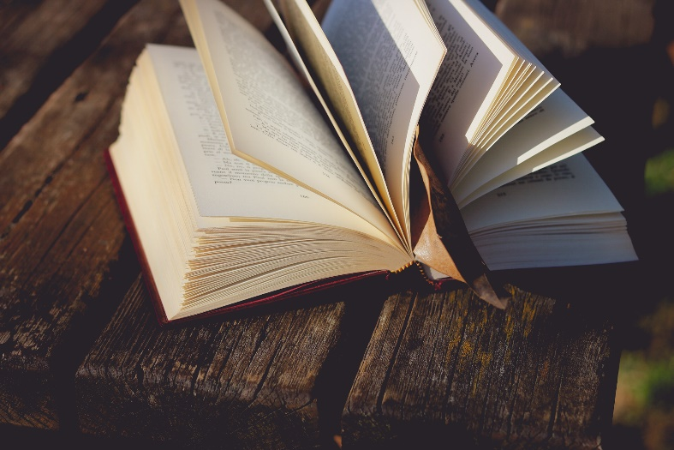
This year, we have not been able to get out and about much. Reading and television have become important to many and, for myself at least, working with our Environment Book Clubs has provided the opportunity to give some thought and learn more about some of the issues with which our popular environmentalists are involved. Namely, David Attenborough and Chris Packham, both naturalists, TV presenters, photographers and authors. David Attenborough treads carefully on these matters, but the younger Chris Packham is more forthright. Both are trying to tell us that the natural world is dying, and we have to do something about it. Chris Packham makes the point, presenting an apocalyptic vision: ‘We have become Death the destroyer of world – the world – very likely the only world in the known universe. And still we overbreed, spit carbon into the air; massacre other species; crush ecosystems and burn our precious planet’ (BBC2 programme transcript). His is an alarming and calamitous forecast for our future and he makes the case that the natural world – its care; its rescue – should be firmly in our minds.
Yet both hold hope for the future. We might call this ‘resurrection hope’.
We might call the catastrophe of our environment human sin. Meaning, when humans turn from the life-giving God and try to find life elsewhere. God’s way of life can be demanding at times, it’s no easy ride. As usual, we are asked to go beyond our individual comfort zones, and look at the wider picture; beyond our own backyards and into the life of the wider societal and ecological world. This is what we are doing when we go outside for a walk with our family or our friends.
Each spring we welcome new growth, new life and new birth - lambs, chicks, flowers, rabbits and eggs. As we grow older (although still enjoying an Easter egg) we might think more deeply about dying and new life, and wonder what God’s promises hold for us. And this is where our new understanding of the ‘interconnected of all things’ really comes into its own. Creation is a chain reaction. It’s about us, yes, but it’s also about all that is around us, and of which we are a part (not apart). We need a widening of the perspective of salvation which is to include the whole cosmos. Climate change teaches us in an almost experimental way that our actions influence not only other humans in a positive or negative way but also the whole universe (cf. Romans 8.19-22).
For fresh inspiration, can I recommend a short story called The Man Who Planted Trees, written by Jean Giono, who gave life back to an abandoned area just by planting trees. The author tells us that the man Elzeard ‘knew how to bring about a work worthy of God’; he was able to transform a deforested desert into the land of Canaan, with the strength of his hand and determination. As a result of the creation of the forest (which stretches for miles), a natural chain reaction takes place. Water comes back, followed by vegetation, natural cycles and the mildness of the climate, families move there, social ties are formed again, cultures and farms appear; in a word there is happiness and new life.
So as well as continuing with the recycling and reducing our carbon emissions, let us be renewed from the inside, let our spirits be refreshed, and our resolve renewed. That’s what resurrection hope is all about.
If you would like to know more about the Diocesan Environment and Literature Book Club go to www.leeds.anglican.org/environment/training-opportunities

