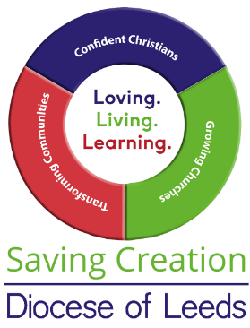**Collects for Creation**

Here you will find a sample of collects from the Lectionary (2022 dates) which illustrate how care for God’s creation can be drawn to the attention of the worshipers.

**Trinity Sunday 12th June**

‘…keep us steadfast in this faith,…’. What does being steadfast in faith mean for our care of creation?

**Corpus Christi 16th June**

‘…the fruits of your redemption…’ The Christian life is described in terms of nature.

**Trinity 1 19th June**

‘…we may please you both in will and deed…’ How can we please God with our care for creation?

**Trinity 2 26th June**

‘…pour into our hearts that most excellent gift of love…’ How can God’s love for us flow out to his creation?

**Trinity 3 3rd July**

‘…and all creation…’ How can we include all creation into God’s plan of salvation?

**Trinity 4 10th July**

‘…increase and multiply upon us your mercy…’ How can we show mercy to creation?

**Trinity 5 17th July**

‘…in their vocation and ministry…’ What is your vocation to care for creation?

**Trinity 6 24th July**

‘…loving you in all things…’ How can our love for God be shown in the way we treat his planet?

**Trinity 7 31st July**

‘…increase in us true religion…’ What does true religion look like in our care for the environment.