Saving the Planet and Saving Money?

Managing our finances is not easy at the moment. Prices are rising on pretty much everything from fuel to food. Some people are being hit much harder than others since they were already living on a tight budget.
Just as the need for food banks is rising so the ability of people to donate is diminishing. In the face of these challenges, and despite the extreme heat, the climate and ecological emergencies have slipped down the list of priorities for some. This is understandable. And yet, saving money whilst still working on saving the planet is not impossible. So here are a few suggestions that will both save money and contribute to building a sustainable future:
- Cutting down shower time from 10 minutes to 8 minutes (and not many of us need 8 minutes) could save you £43/year for each person in the house.
- Switch from tumble drying your clothes to air drying them whenever possible. This could save up to £180/year
- Switching to LED lightbulbs will save you MORE money than sticking with old style ones and remembering to switch off the lights every time you leave a room.
- Turning off electric devices at the wall: the more you have to turn off, the more you will save e.g. one games console regularly turned off at the wall can save you up to £25/year
- Boil a full kettle in the morning and store the water in a thermos for hot drinks throughout the day.
- Wash clothes at lower temperatures. Even moving from 40 degrees down to 30 could save you £12/year
All of the information above come from www.thisismoney.co.uk It will both save you money and reduce your carbon footprint.
A few other things to bear in mind:
- Planning meals to avoid food waste will save money and reduce carbon and methane emissions
- Buying ‘wonky’ fruit and veg is also a double win
- If you have school age children, follow Zero Waste Leeds on Facebook and make use of their ‘school uniform exchange’ scheme
- Make use of websites like ‘Freegle’ and ‘Freecycle’ to both give and search for items: no cost and no extra carbon.
- If you have a smartphone, make use of ‘Olio’ and ‘Too Good to Go’ to track down free (Olio) or very cheap food offers
And finally, should any of us be in the fortunate position of having some savings available, this could be a very good time to invest in personal energy saving measures such as extra insulation, double/triple glazing, fitting solar panels etc. OR ensuring that our saving are invested ethically to help build the sustainable future we are working towards. These words of Jesus from Matthew 6:19 take on a new meaning in our present global situation: “Do not store up for yourselves treasures on earth, where moth and rust consume and where thieves break in and steal.”

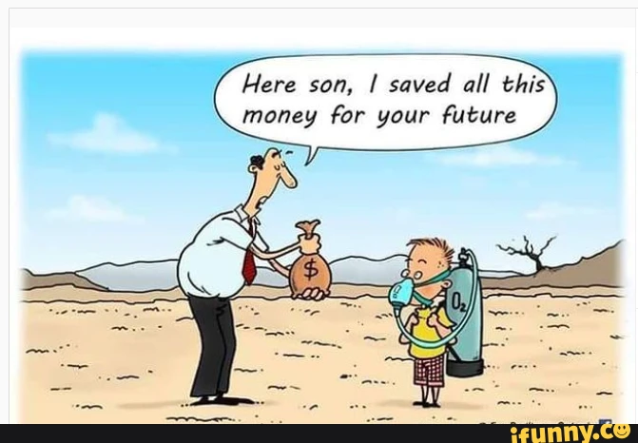

Jan Goodair
Area Environment Champion, Leeds

