Is it for our Grandchildren?
I’m sure like me you have hear people say “Yes, I want to do something about climate change because I’m worried about what sort of planet we will leave for my children and grandchildren”.
But right now is it children and our grandchildren, our next generational neighbours that we should be concerned about? In the immediate term, I’m more concerned about the more mature members of our churches and communities, who are currently the most vulnerable to the impacts of our warmer world.
Recently thousands of elderly Swiss women joined forces in a ground-breaking case heard at the European Court of Human Rights, arguing that their government's "woefully inadequate" efforts to fight global warming violate their human rights.
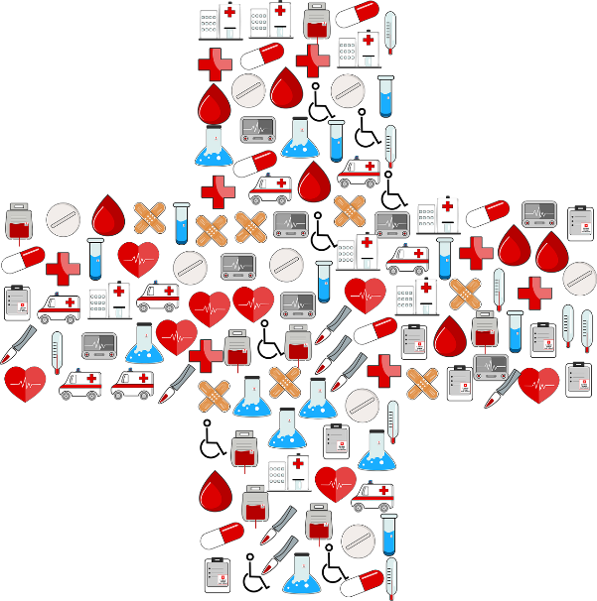
The Club of Climate Seniors, as they are known, have an average age of 73. They say climate change is putting their human rights, their health and even their lives at risk. In the last 20 years, heat-related mortality in people older than 65 in Europe has increased by more than 30%.
In Yorkshire we have now all experienced this kind of high risk heat event. On 19th July 2022 temperatures reached 40^{O}C. This year, June has just been certified as the hottest on record. As well as increasing mortality rates, because of the challenge to keeping your body cool, heat events can exacerbate respiratory conditions like asthma.
What can we and our churches do? Global warming is a big one to sort out. Taking seriously the Church of England’s call to cut the carbon emissions of the church is a good starting point.
Become net zero carbon church is a symbol. By itself it will not prevent global climate change. However, it stands in a long and biblical tradition of prophetic action drawing attention to all that runs counter to God’s will and the common good. The Kingdom of God is characterised by justice, peace and ecological wholeness. The vocation of the church is to be sign, a sacrament, and a foretaste of Christ’s Kingdom.
Secondly, what opportunities are there for your church help in heatwaves? Most churches with their old historic thick stone walls are ideal “cool places”, providing sanctuary on the hottest of days and even cool sleeping places at night (when most avoidable heat related deaths occur). Last year, some local churches got busy offering ice lollies and cold drinks to local residents.
Putting in place a climate resilience or adaptation plan can help every church to be prepared for our changed and changing climate.
At home we can show our love and concern for our elderly neighbours too. Making choices in our daily lives that help to cut our carbon footprint: travelling less and by public transport when we can; cutting our consumption of stuff; reducing our home energy use where possible; and eating more a more plant based diet.
Our conversations can be powerful too. Hot does not always equal happy days. Helping to decouple the British obsession with a desire for heat waves and mild winter days and raise the alarm on this climate catastrophe is something we can all do.
Jemima Parker
July 23

