External Noticeboards
DAC Advice for PCCs

When did you last change the information on your church noticeboard? Is it up-to-date?
A church noticeboard is often the first point of contact for visitors. In today’s visual age it is important that noticeboards provide a positive image of the church. A noticeboard which looks worn, dated, or which contains incorrect information does not reflect well on the church itself and may either deter visitors or make it difficult for them to contact the incumbent.

- Location
When a PCC is first considering how to change its noticeboard, location is an important consideration. Boards should be located in the area of greatest footfall which may not be in the traditional location next to the main gate. Instead, the board could be relocated so it is looking out onto the street or at the entrance to the church car park. It’s also important to check that the board is not partially hidden by trees or shrubbery.
Signage can be erected on church land without permission from the local planning authority, provided that the sign is no larger than 1.2m². This should be borne in mind when considering the design of your noticeboard. Further information on permissions can be found under the heading ‘Permissions’ below.
Some points to note: If the board is to be placed outside church land (e.g. in a Vicarage garden or on land owned by the church but outside the boundary walls), planning permission will be needed for the board, irrespective of the size. If the board is to be relocated to an area where burials may have taken place, an archaeologist may need appointing to oversee any digging into the churchyard to place the posts.
- Design
The next decision of a PCC is to choose the design of the noticeboard. There are several different layouts for boards; these are the most popular:

The board to the left contains static information about church services and contacts.

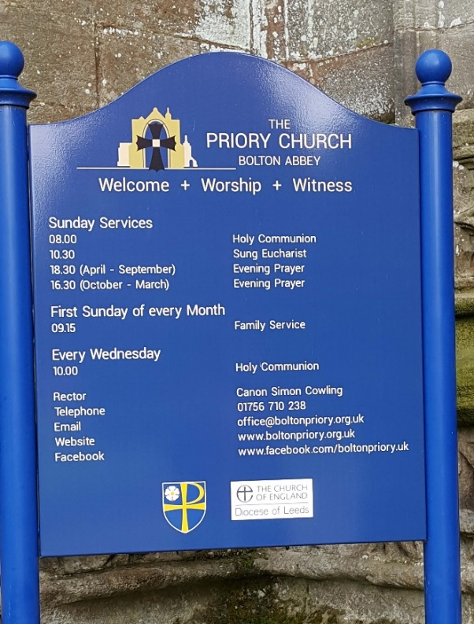

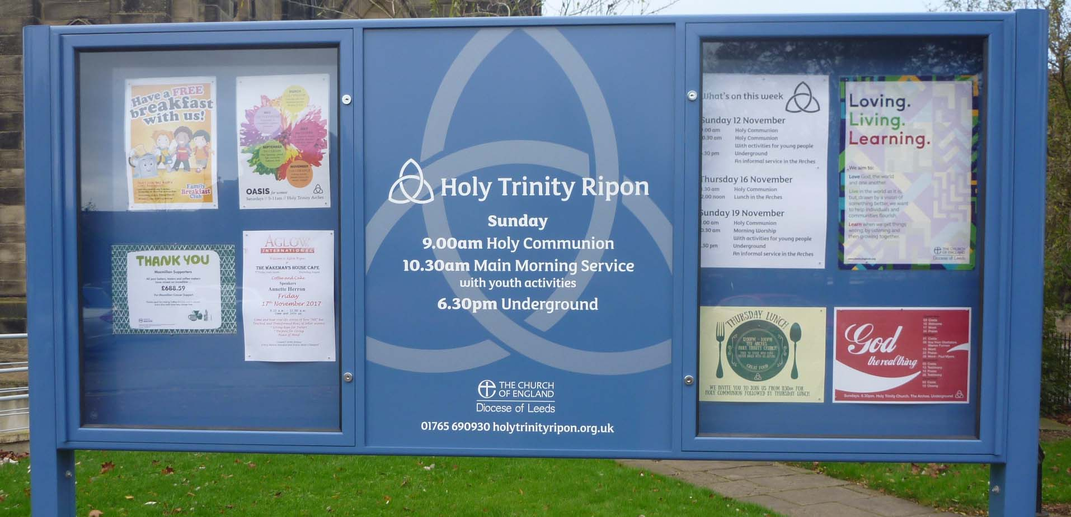
The board above has space for static information, plus space to include posters or advertisements for events and special services. Some boards of this type have only one lockable display cupboard.

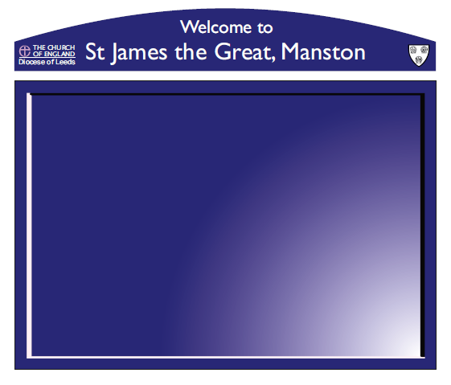
This board has the name of the church and diocesan logo with a large space to display interchangeable information regarding services and to advertise for events.

Many modern church noticeboards are made from coloured aluminium with vinyl lettering, mounted on aluminium poles. These are attractive, durable and easy to amend when a new incumbent arrives or services change. Some churches prefer to use wooden noticeboards which are also attractive but will need regular maintenance or repainting to prevent the wood from rotting. Please ensure that a regular maintenance routine is established for repainting or re-varnishing external wooden boards to prevent wear and tear from the elements.
The colour of the board is another factor to consider. The diocese does not have a set colour for noticeboards so PCC’s may wish to use the preferred church colour instead. Be wary of using a colour that is too dark with dark lettering as this will be difficult to read from a distance. It is also worth considering a fairly conservative colour scheme; boards with clashing colours may catch the eye, but not necessarily for a good reason. It is better to have one block colour for the board and another colour for the lettering. There is increased recognition that some people find it easier to read dark colours on a light background and this could be a consideration when designing the board.
- Wording
When choosing the wording for the board it is better to keep text to a minimum and only include important information that will not change over time.
Information that must be included on the board:
- The Diocesan logo
- The name of the church
(The Diocesan logo is available on the Diocesan website. It can be downloaded as several different file types as different sign manufacturers will have different requirements. The logos on the website are provided in the preferred colours, but consideration may be given to variations to this, if it benefits the overall appearance of your noticeboard.)
Information that should be included on the board, either as the main wording or on display in one of the cabinets:
- Regular service times and details
- Contact details for the incumbent and any church office
- The website address for the church – which may contain any transient contact details such as those for a curate.
Information that could also be included:
- Contact for hall or room bookings
- Church logo
Consideration of the font type and size is important to make your board readable. The British Dyslexia Association recommend using a plain, evenly spaced sans serif font such as Arial, Verdana, Tahoma and Trebuchet. These fonts are clear and easy to read even at a distance, unlike flowery script-like fonts. Avoid using all capital letters as this can be difficult to read when used for a block of information.
Another important factor is to ensure that the wording is grammatically accurate with no spelling errors. Avoid repetition: For example if there is a heading called ‘Sunday Services’ then it is not necessary to list the service as ’10.00 Sunday Holy Communion’ or ‘Main Sunday Family Communion’. For an idea of how to arrange the information on a noticeboard and some of the grammatical pitfalls, please see the example mock up at the end of the advice document.

- Permissions
If an external noticeboard needs replacing like-for-like, repairing or repainting, or the lettering changed to add the name of a new incumbent or church service, this can be done under List A of Schedule 1 to the Faculty Jurisdiction Rules 2015 (amended 2022) and does not require consultation or any form of prior approval.
A new noticeboard or a replacement noticeboard of a different material or design within the boundary of the churchyard requires List B permission under Schedule 1 to the Faculty Jurisdiction Rules 2015 (amended 2022). This can be obtained from the Archdeacon via the Online Faculty System. As part of the List B application you should provide the following documents:
- A PCC Minute with a resolution agreeing to the proposed board;
- A mock-up of the board showing the exact dimensions, colour, wording and design;
- Photographs of the existing board and the location of the new board;
- If the board is to be affixed to the church building or churchyard wall, the Inspecting Architect will need consulting on fixings. His or her comments will form part of the paperwork. If the board is freestanding on posts, the comments of the Inspecting Architect are not necessary;
- If new posts are to be sited in a new area where burials may have occurred, an archaeological Written Scheme of Investigation is needed;
- Notification of any advertising planning consent (see below).
For more information on registering and using the Online Faculty System to apply for List B permission for a noticeboard, please contact the DAC officers below.
If the noticeboard is larger than 1.2m², Advertising Consent must be obtained from the local planning authority. There is usually a cost associated with making such an application. The process for obtaining consent will vary between different local authorities, contact the planning department to establish what the requirements are for your area. Advertising Consent is usually time-limited to five years, so the conditions of any permission granted should be checked carefully and consent renewed in a timely fashion, if required.
As with all matters to do with church fabric, the DAC officers are available to talk through any issues regarding a new noticeboard. Please contact us at the following:
Lisa McIntyre DAC Secretary lisa.mcintyre@leeds.anglican.org 0113 3530277
Rob Andrews Team Coordinator rob.andrews@leeds.anglican.org 0113 3530278
Stephen Craven Church Buildings Officer stephen.craven@leeds.anglican.org 0113 3530274

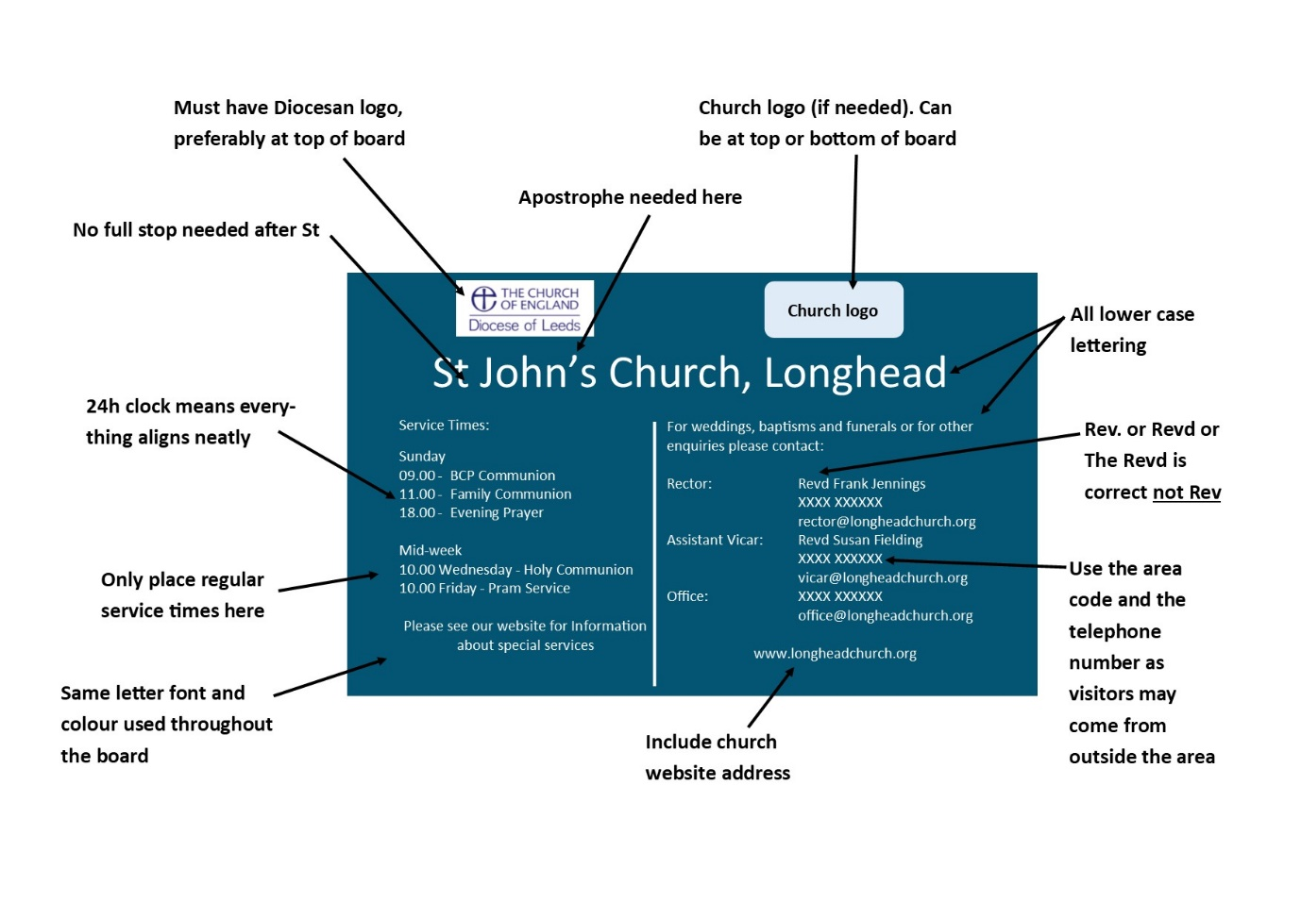
- Example of a typical church noticeboard

