THE FORGOTTEN CLIMATE CHANGE BUSTER
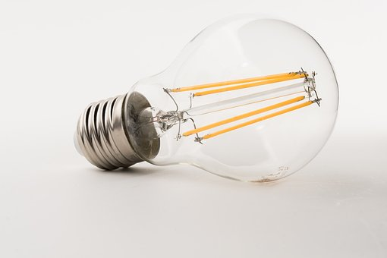
Much of the focus of climate change policy of both government and some campaigning groups has been to get us all to switch to renewable electricity (e.g. electricity generated by wind turbines, solar panels and hydropower) and away from electricity from coal or natural gas power stations. Unfortunately, the very positive role that energy efficiency can play in reducing our carbon footprint has been marginalised.
For example, the cheap loans or grants that were available to many householders to better insulate the nation’s old housing stock have largely disappeared even though heat losses from poorly insulated homes can result in fuel poverty and offer a major opportunity to reduce our carbon footprint.
According to government data analysed by Carbon Brief, despite it being the poor cousin to renewable energy, energy efficiency measures have reduced our energy demand by a whopping 103 twh (terawatt hours) a year whilst the growth of renewable energy has cut our use of fossil fuel energy by a little less – 95 twh a year.
Much of the energy efficiency savings have come about because of higher standards for energy efficiency on the newer appliances that we buy and use regularly – fridges and freezers, washing machines, dryers and vacuum cleaners as well as lightbulbs. For example, changing your old B- or C-rated fridge to an A++ can halve the electricity used by that appliance.
Replacing a single old incandescent lightbulb with a modern low energy LED light bulb may well make an insignificant contribution to cutting the carbon emissions which are warming the planet. But if millions do it – as they have – their efforts make a substantial dent in the UK’s and the world’s energy demand. They have made a real difference.
The overall result is that electricity generation in the UK is now back at 1984 levels. That is real progress.
The increasing use of on shore wind turbines, industrial solar panels in farmers’ fields and even hydro projects for generating renewable energy is somewhat controversial whilst some other ways of reducing personal carbon footprints significantly affect personal lifestyles (e.g. driving and flying less, eating less meat). But introducing energy efficiency measures in the home is less controversial, does not restrict lifestyle choices and can be just as, if not more, effective.
In my own Church, we have been actively introducing energy efficiency measures. A modern boiler and hot water system in the Parish Centre; roof insulation in the vestries and Parish Centre; and new energy efficient lighting under the balcony in the church and in the Parish Centre. And let’s not forget the bike rack at the front of the church to encourage visitors to cycle to our building rather than drive!! And on top of that, we are now switching to using 100% renewable electricity. So, we trying to practise what we have been preaching.
David Eggleston
Christ Church, Harrogate
(Article based on item on BBC News Science and Environment webpage dated 3/1/2019)

