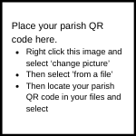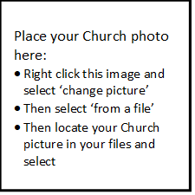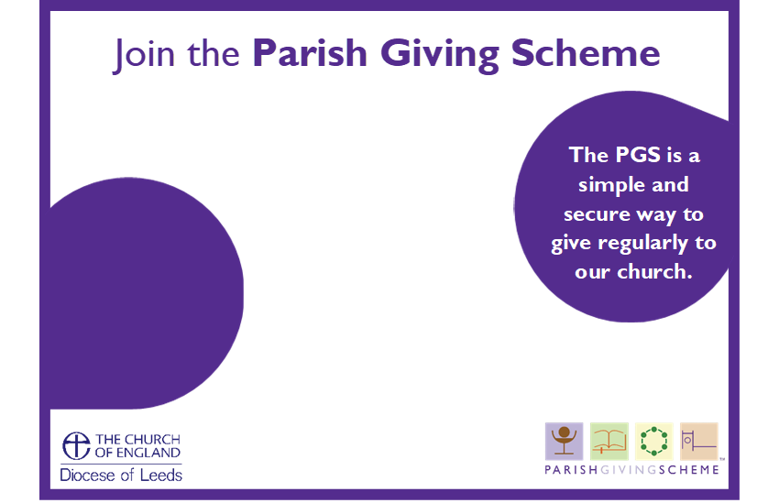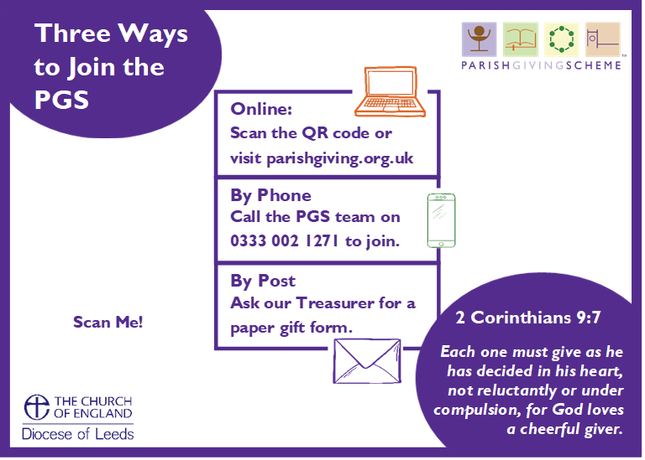

**PGS Code: …………………**

**Chat to [NAME] to find out more!**

**[CHURCH NAME]**

**PGS Code: …………………**

**[CHURCH NAME]**

**Chat to [NAME] to find out more!**