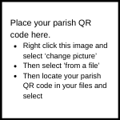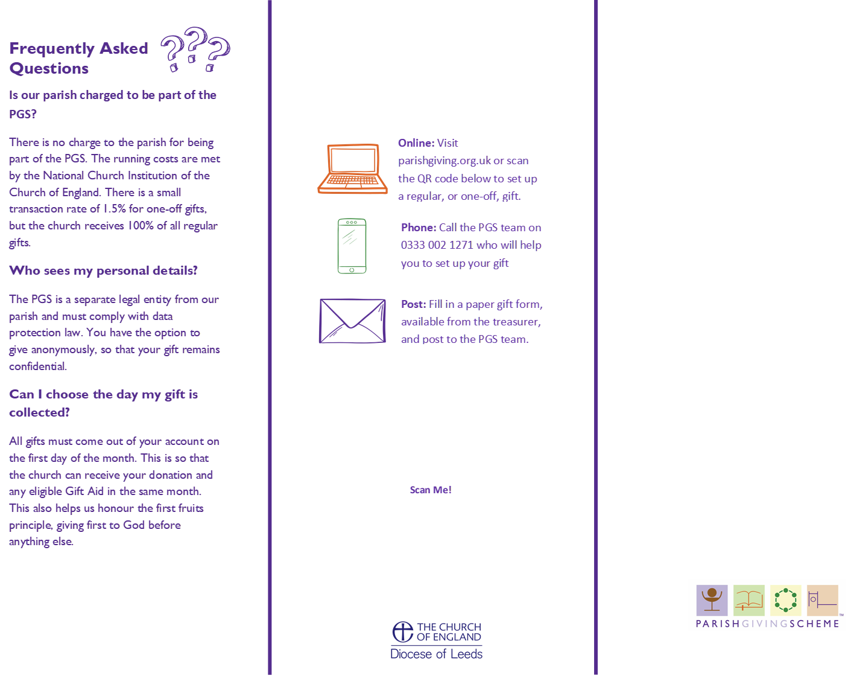

**Get in touch with our treasurer, [Name], with any questions or concerns you might have: [Treasurer Contact].**

**Support the work of [Church Name] by joining the**

**Parish Giving Scheme**



# 3 Ways to Join the PGS

There are a few different ways to set up a regular gift with the PGS. You will need our PGS parish code to sign up, this is: **[PGS CODE].**

**Thank You!**

Your giving makes everything we do at **[Church Name]** possible. Thank you for your generosity.

**Get in touch with our treasurer, [Name], with any questions or concerns you might have: [Treasurer Contact].**

**Support the work of [Church Name] by joining the**

**Parish Giving Scheme**

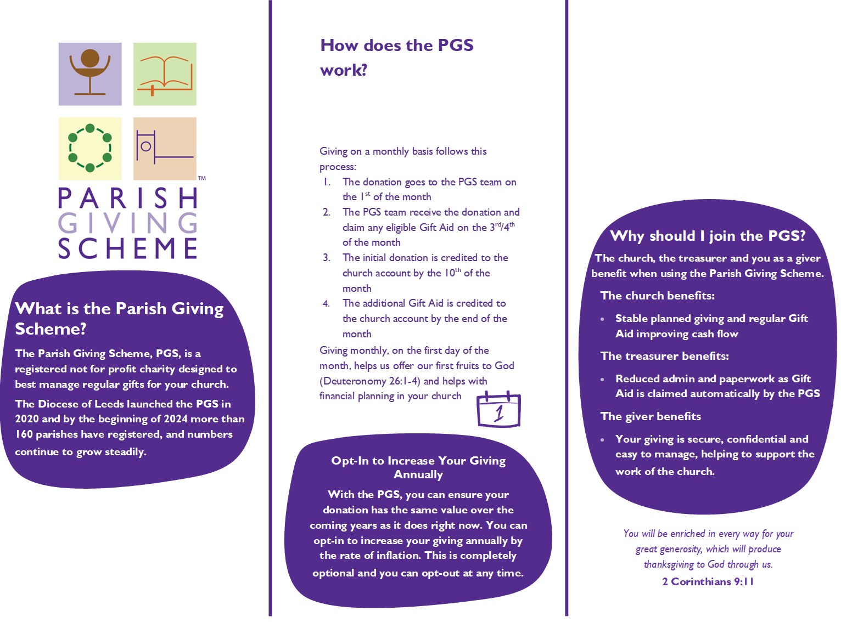

Please take a moment to read through the details in this leaflet to find out more about giving to **[Church Name]** using the PGS.

We are so grateful for your support.

The PGS is a safe and secure way of giving regularly to **[Church Name]**. Regular giving can be giving monthly, quarterly or annually.