Trees of Life

“When you lay siege to a city for a long time, fighting against it to capture it, do not destroy its trees by putting an axe to them, because you can eat their fruit. Do not cut them down to use in the siege, for the fruit trees are for the benefit of the people.” Deuteronomy 20:19

This piece of advice comes from a passage aimed at the people of Israel which sets out what is and is not permitted in time of war. An appreciation of the benefits of trees to us as a species is, it seems, nothing new. However, our appreciation now is much deeper than that of the writer of Deuteronomy: they saw the trees only as a source of food, so if ‘you’ weren’t a fruit tree then, sadly, you were for the chop!
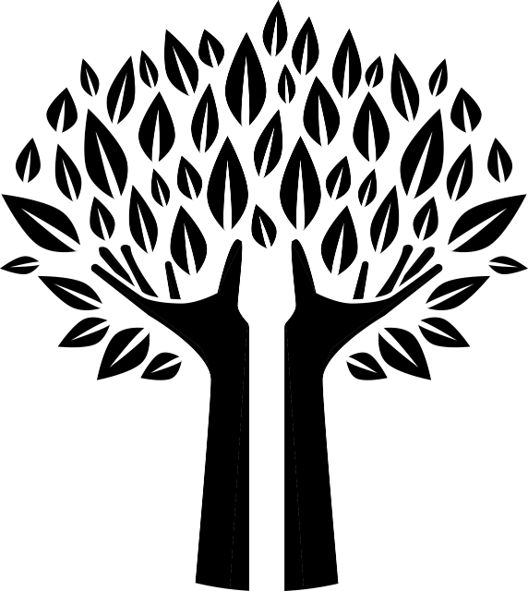
Yes, trees do still provide us with fruit, but now we also understand the key role they play in absorbing and storing carbon dioxide, one of the key global warming gases. An excess of carbon dioxide in the atmosphere is one of the key drivers of the climate change that is now affecting so many parts of the globe. (I make no claim to being a scientist, so please excuse the simplicity of my explanations.) The Amazon Rainforest has sometimes been described as the ‘lungs’ of the earth as the trees of the forest absorb CO2, break it down and then release oxygen. The rainforests are also places of enormous biodiversity, supporting the lives of innumerable species of plants and animals, all of which contribute to the overall balance of life on earth. And yet we continue to cut down those life sustaining forests. Why? To clear land for the grazing of cattle, to grow soya which is mostly fed to intensively reared farm animals and to produce the palm oil which seems to be an ingredient is so many processed foods. (Take a moment to look at some of the packets in your cupboard.)
In the book of Proverbs (31:8) we are told, “Speak out on behalf of the voiceless, and for the rights of all who are vulnerable”. We have usually understood this in terms of our obligations to other human beings, but the other-than-human creation also needs us to speak. And because of the wonderfully connected world in which we live, when we speak out for the other-than-human, we will find that humankind also benefits. If we protect and look after the trees, they will be able to continue to protect and look after us.
So what might this mean for us in practical terms? We might consider joining and financially supporting an organisation like Rainforest Rescue or, in the UK, The Woodland Trust; if we have space in our own gardens, we might plant a tree; we might volunteer to help out with local tree planting schemes. And as COP26 approaches, we might also think about making contact with our MP and letting him/her know that this is something we really care about. Trees are mentioned in the Bible more than any other living thing apart from God and human beings. They clearly matter. If you are a reader of novels and would like to be even more convinced of just how much trees matter then you might like to try reading ‘The Overstory’ by Richard Powers – a truly remarkable book which includes an account of a tree who sacrifices herself for the sake of others. Does that sound a familiar story?
P.S. Not very connected, but choosing peat free compost really helps too!

Rev Dr Jan Goodair
Joint Area Environment Champion – Leeds

