Zero Carbon Church: You must be Joking!
By Jemima Parker
I can always get a laugh or at least a raised eyebrow by explaining that as part of my role as environment officer for the Anglican Diocese of Leeds, I’m encouraging our 600 or so churches to become carbon neutral in the next ten years. However, for many churches this will be quite a simple exercise that could be achieved this year. How?
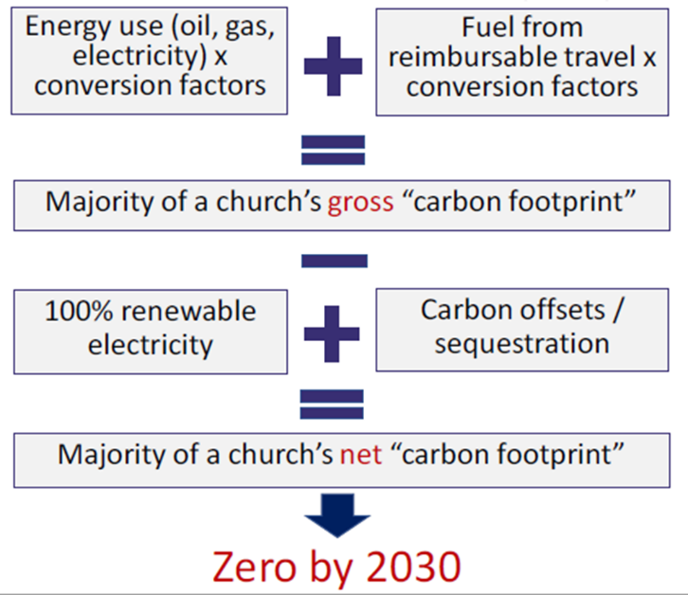
Firstly, we need a bit of clarity on what net zero carbon or carbon neutral means. The Church of England has decided to start by only counting its Scope 1 and Scope 2 emission for the commitment to be net zero by 2030. That means carbon dioxide produced from directly burning fossil fuels (gas/oil heating and petrol/diesel used for church business travel) and carbon emitted from using fossil fuels to generate electricity.
What about the “net” carbon emission? Some activities take carbon dioxide out of the atmosphere for example as trees grow they lock carbon into their leaves, trunks and roots and store it away. So tree planting can count as a carbon offset.
There are four steps to take to become a carbon neutral church.
Number 1: Measure the carbon footprint of the church. The new Energy Footprinting Tool which is part of the Online Parish Returns does most of this for you when you enter your energy bills. Or you can use the 360Carbon tool on the Climate Stewards website. Now you know where your carbon is coming from.
Number 2: Switch your electricity supply to a 100% renewable tariff. You can do this through the diocesan Green Journey scheme or another supplier. Now you have a clean no carbon electricity supply. If your church heating is electric you are nearly at net zero.
Number 3: If your church heating is gas or oil there are some longer term plans to be made to replace this with an electric based system such as under pew heating, electric radiators, far infra-red panels, air source or ground source heat pumps. In the meantime you could switch to a carbon offset gas tariff (such as the one offered by the Green Journey) to compensate.
Number 4: Church related travel may be a bit more complicated to calculate. Clergy and volunteer travel expenses or a survey to estimate these journeys by car will provide a reasonable evaluation. Reducing journeys by car, switching to public transport or active travel for those that can, car sharing and holding some meetings online will all help. Over the next ten years the move to electric vehicles will cut emissions for remaining journeys. What remains needs to be offset to bring the balance to zero.
There are many reputable and local carbon offsetting schemes, Climate Stewards is a Christian charity that offsets carbon at a cost of £20 per tonne of carbon dioxide. So if a church had 4 tonnes of carbon left after switching to a renewable electricity tariff, it would cost £80 a year to be net zero carbon.
There are a number of churches locally and nationally who are already carbon neutral, why not join them?
More detailed advice is available on the environment pages of the diocesan website www.leeds.anglican.org/environment/zero-carbon-church

