What do we do with the leftovers?

“After everyone had eaten all they wanted, Jesus' disciples picked up twelve large baskets of leftovers.” Matthew 14:20

The Feeding of the 5000 is the only one of Jesus’ miracles to be recorded in all four gospels, so it must be an important one. It speaks of God’s generosity and God’s ability to supply abundantly all that we need. But have you ever wondered what happened to those 12 baskets of leftovers? Did they feed them to the birds? Or perhaps take them to the next village and share them out there?

One thing I am pretty certain of is that they will not have simply been ‘thrown out’. (Where is ‘out’, by the way?) Wasting food was definitely not the done thing back then: “Even the dogs eat the scraps that fall from the children’s’ table.” Mark 7:28

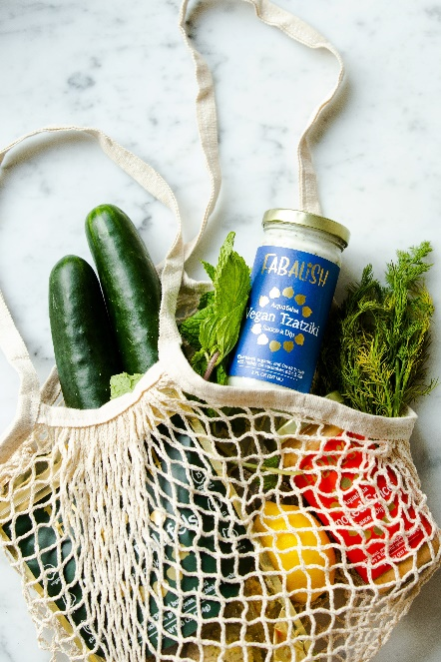
Food waste today is a very different story. Some of it is wasted on farms, some in the production process, and some within our homes as we forget what is in the fridge or scrape leftovers into the bin.

Here are a few random facts about food waste for you, some of which really ‘boggled’ my mind:
- 30%-50% of food produced for human consumption is wasted annually
- The average family in Great Britain wastes nearly £60 a month by throwing away food, in some cases almost an entire meal a day
- Food waste that goes to landfill produces methane, a global warming gas much more harmful than carbon dioxide
- Food waste is responsible for 8% of global warming gases, about twice that of the aviation industry
- Food waste is responsible for over 170 trillion litres of water annually

So what can we do to help address the problem? Here are my ‘top tips’:
- Plan your meals and make a shopping list so that you buy only what will be eaten.
- Deal with any leftovers you still have by investing in a suitable compost bin, if you have the space (No methane produced this way).
- If you have a garden, grow some of your own vegetables and pick what you need as you need it.
- Buy the ‘wonky’ fruit and veg which would otherwise be wasted. It’s often cheaper too.
- If you have a smartphone then download the ‘OLIO’ app and offer the food you are not going to eat in time to other people (I once over-catered for a family gathering and was able to pass on a large tray of sandwiches and snacks this way).

By trying to reduce our food waste we can help to keep global warming as low as possible, save money, save water and almost certainly feed more people – as long as we remember to share.

Wouldn’t it be wonderful if, by small changes to our habits, we could point the way to a well-fed, sustainable world –pointing the way to God’s kingdom where all life flourishes.

Jan Goodair
Area Environment Champion, Leeds

