My Lent Challenge: A Plant Based Diet
Jemima Parker, Environment Officer for the Diocese of Leeds
Note: All food carbon “forkprints” figures are given as kilograms of carbon dioxide equivalent for a kilogram/litre of the product and taken form My Emissions Food Carbon Calculator.

“Wow, that’s hard!” my friend texted back to me. Having a plant only diet (vegan) had felt like the right sort of spiritual challenge for me this year.
To be honest I’ve not been much good at Lent challenges. Lenten prayers, reflections or daily good actions have often not motivated me and I’ve failed to be disciplined in implementing them for six weeks. But as Ash Wednesday approached I realised this brought together both the spiritual and practical sides of my Christian faith. Here was a way that I could express love, joy and hope within the context of the Lent themes of discipline and self-sacrifice.
“It’s not too bad, it’s really only cheese (7.4), eggs (4.5) and butter (9.7) to cut out” I texted back. My family and I have been changing our diet gradually over many years. We cut back our meat consumption initially because of health concerns about processed red meat linked to bowl cancer. Later, as we became more climate aware, taking on board the greenhouse gas cost of eating beef (43.3) and lamb (20.8) (cows and sheep burp a lot of methane).
Gradually trialling new recipes we have moved to be “flexitarians”, just having meat as a treat, with lots of tasty vegetarian meals as our main fair, with plenty of protein from beans and pulses such as chickpeas (0.8), from nuts (1.3) and seeds (0.8) and also cheese and eggs. This has echoes of an older, more traditional diet, pre cheap unsustainably produced meat, but thankfully with a lot more variety and flavour.
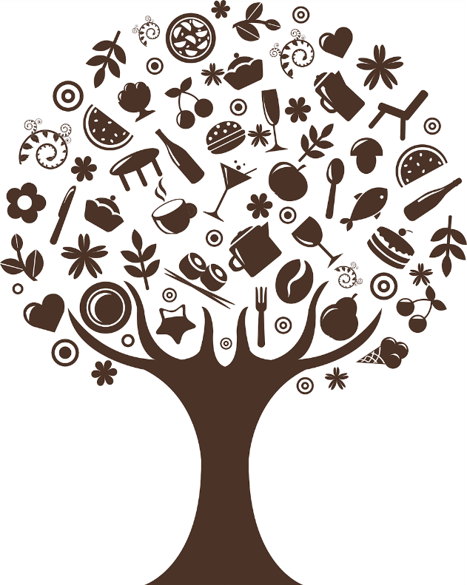
We have come to enjoy eating seasonally to avoid excess transport emissions, particularly from perishable fruit and veg being air freighted. Waiting for plums (1.1) to come into season in August or feasting on corn on the cob (1.5) in September all adds to our appreciation of what we have on our plates.
“I sorted out milk (1.3) last year” I explained to my friend. I have to own up to this being my second attempt at a vegan Lent, I tried in 2020. I gave up at the end of March when the first lockdown swamped our regular organic supplier with new delivery orders and we had to fall back on our store cupboard tins for a few weeks. The thought of not using dairy milk had been a big one for me then, but I switched to oat milk (0.3) and soya (European grown) milk (0.5) and yogurt and now a year on I actually prefer it!
So where is the spirituality in this? Focusing on my diet reconnects me with God, as creator and provider. None of us can exist separately from the natural world, although often we seem to act as if we are not an integral part of Christ’s cleverly woven together planetary ecosystem. What I put on my plate reminds me of this, making me consider where it from, how it was manufactured and of my impact my food has on the soil, water and ecosystems where it is grown or reared.
It also brings me great joy, I love eating with others and I love food! Our nuclear family meals have been special this year, we have had more time for each other. I also look forward to eating with my wider family and friends again.
Preparing food for others is a great way to show our love. But our love for our friends, neighbours and future generations can also flow through our food choices. Globally 20-30% of greenhouse gas emission are generated through the food we eat and throw away.
The UK Committee on Climate Change who advice the government on our national carbon budget, call for a reduction in our consumption of high-carbon meat and dairy products by 20% by 2030. This is an average, so some of us will have to act generously and do more, because, as with other inequalities, others don’t have the ability, knowledge or skills to change.
Isn’t my diet going to put our local livestock farmers out of business? Our farmers, the custodians of the land, are on the front line of climate change, they need our prayers. I know a Ripon farmer who has joined Extinction Rebellion, such are his concerns about climate breakdown and how changing weather patterns make managing his land less predictable.
The transition to low carbon farming techniques will take time. Supporting this transition by eating seasonal, local fair and paying an appropriate price for meat and dairy products is part of the way forward, remember meat is a treat. The new government Environmental Land Management Scheme which pays farmers public money for public “goods” is starting to steer our countryside to a more sustainable future.
“We’re doing a family sugar fee Lent” replies my friend. I think this through… that’s no puddings, jam (2.1), biscuits (1.3), cake or chocolate (5.7) and text back “Wow, that’s really hard!”
You can explore your own carbon forkprint at www.myemissions.green or look in more depth at decarbonising UK land use and food production by reading the Zero Carbon Britain Report on the Centre for Alternative Technology website.

