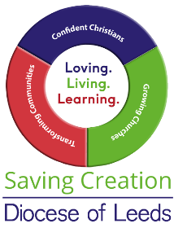
Parish Parishioner 8: Let’s have a green Christmas …

Part 1

Sue Young

Any sort of celebration these days is usually synonymous with consumerism and excess. Retailers jump on the band wagon of any special day. As this piece goes to print our local shops will have begun to inundate us with festive jingles, supposedly to encourage us to buy ‘stuff’ for family and friends, that not only denudes our precious, limited planetary resources, but then is most likely, to be casually ‘thrown away’ (bearing in mind there is no such place as ‘away’).

None of us need any more junk at home, yet we are drawn into the consumerist web, spending money the energy crisis has ensured we don’t have, on goods that we don’t need or want. An extra 30% of our rubbish is produced and discarded at Christmas time and the average British adult spends over £500 on gifts (I am not personally convinced by that figure, given the recent immense cost of living increase, I imagine that expenditure figure is much higher). Those that know me, or have read any of my previous magazine offerings, will be thinking that my comments amount to ‘pot calling kettle black’, as I am notorious for my profligate overspend on friends and family, so this festive time I do need to heed my own advice.

Christians know, from childhood, the story of the birth of Jesus. The Kings /Wise Men brought gifts for the new baby, but not the modern equivalent of the entire Amazon warehouse for each grandchild (a true exaggeration, but one levelled at me in past years).

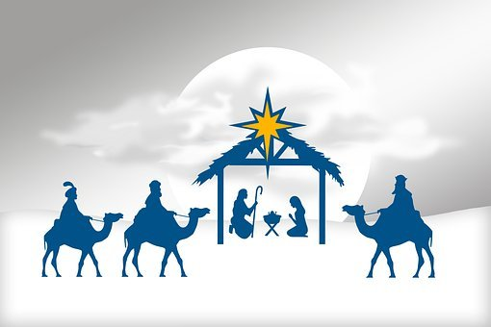
Talking with one such grandchild recently, about my need to cut back on presents this year, his usual, cleverly thought out response was that the gold brought by one of the Kings would ‘have allowed Jesus to have anything he really wanted,’ and he guessed ‘that could include not only a new donkey, but a new carpentry set for Joseph too.’ Frankincense he knew was an expensive perfume and he thought Jesus’ mother would have enjoyed that gift after giving birth in a dirty stable. Myrrh, he had heard from school, ‘was used to embalm Egyptian pharaohs and maybe our own late Queen, as she had been lying in that box a really long time before the funeral’.

His message to me was clear…..
‘Jesus got special presents when he was little and one lady in the bible even rubbed his tired feet with her special perfume.’ Presents, he deduced, ‘cannot be all bad, Grandma.’

So how can we approach Christmas with our green hats on, but wishing not to spoil the celebration? The real pleasure we know is in giving of our love, attention and time, when the latter these days, is mostly in short supply for us all.

I am reminded of my late husband Johnathan, who for years insisted on no personal presents, simply the gift of time spent with him. His delight would be an adult child taking him out for the day (the last loved venture was seeing the bluebells in Middleton Woods) perhaps with afternoon tea thrown in. He was simply decades before his time with this, and my gifts this year to the family will reflect his thinking. Offers to babysit for the parents whilst they have much needed time together, and for the children a group present for pantomime tickets in the New Year (oh yes I have!).

In general I try to remember that when I spend my money I am actually casting a vote for the kind of world I want to live in - mass produced plastic tat from China? An appalling fact: the UK generates the weight of 3.3 million emperor penguins in plastic waste each Christmas. Better to vote for fairtrade gifts; organic handmade and sustainably sourced items; preloved items (second hand bookshops are an Aladdin’s cave of opportunities); or make your own.

My home made creations have sometimes been less than successful. I am reminded of attempting years ago, as a novice knitter, to produce a bright coral snood for my newly acquired daughter-in-law. These days I would get advice about colour and design from the intended recipient, and possibly employ an expert friend as a proxy knitting guru. Wisdom and an embarrassing experience years ago, taught me never to claim others’ hand-made knitted goods as created by my own fair hands, for fear of being seen as an expert and enrolled for future orders or charitable ventures.

Another option is to visit local craft markets and the Yorkshire Dales is famous for these. Seldom though nowadays are they flooded with the original knitted toilet roll dollies (Aunt Mildred in our family had a particularly ghastly green and faded white version, that no one would dare touch without gloves on). Instead these colourful roadside village events very often boast a spread of unusual local artisan products, the sale of which can support the local economy.

