Stations of the Planet in the Season of Lent

On the journey to Easter we remember that Christ’s death and resurrection brings healing and renewal for the whole planet and our failings in our calling to care for creation. This resource offers 10 simple reflective prayers for Christ’s broken creation. The Stations of the Planet could be used in a service or as a prayer activity either during holy week or at another time of year.

Lent is traditionally a six-week period when, as Churches and Christians, we are reminded of the foundations of our discipleship, of how we are called to live and to love in today’s world. Our lament culminates in the crucifixion on Good Friday. After the Easter celebrations, we celebrate the resurrection life, working to bring life and hope into many situations and reflect on the actions we can take ourselves.

Through our churches, we are reminded of the historical context in which all this took place, which is usually transmitted through the scriptural readings linked with the traditional Stations of the Cross and Stations of the Resurrection. These ‘Stations of the Planet’ are not intended to replace these important readings, but to add to the global understanding of creation and to illustrate how faith and service, worship and living are held together within the lordship of Christ. Biblical references litter our contemporary literature as society grapples with the existential challenges of the climate and biodiversity crises:
“The Four Horsemen of the Anthropocene: Climate change is a threat multiplier, which exacerbates the other social, environmental, and economic problems that populations face. Fire, heat, drought, and flood will transform our world this century. These four horsemen of the Anthropocene will make much of our world unliveable for people. “
Gaia Vince, Nomad Century (2022)

“There is always a river: song of the herbivores”.
Ruth Padel, The Mara Crossing (2012)
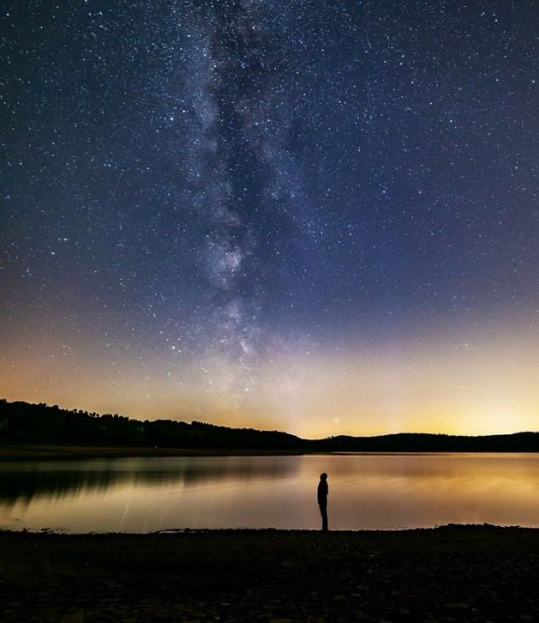

“Trapped between climate change on one end and urban expansion on the other, the checkerspot butterfly, most experts believed was doomed.”
Sonia Shah, The Next Great Migration (2020/2021)

Stations of the Planet

Refrain: The Spirit is willing, but the flesh is weak.
O Lord make haste to help us. And renew the face of the earth

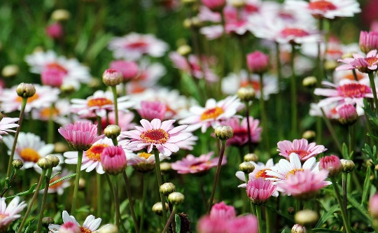
First Station – We fall from the Garden of Eden
We come to you in sorrow for our sins
We are losing our connection with the earth
as we sit in front of our television screens or chat on our phones.
Refrain

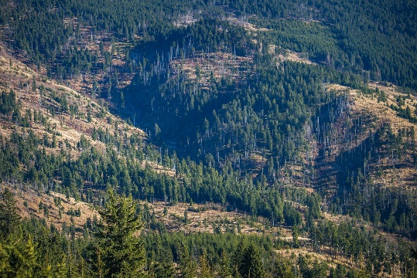
Second Station – We betray God’s trust in our stewardship
Woodlands and forests are cut down
The air we breathe is polluted
By carbon emissions.
Green pastures are suppressed by tarmac and steel.
Refrain

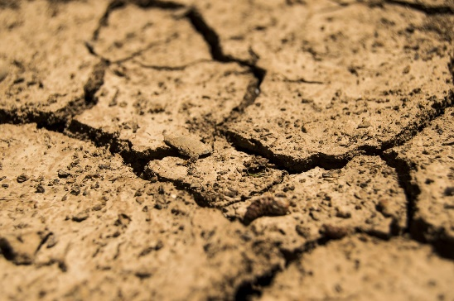
Third Station – We are condemned by our lack of care.
Climate change results in global warming
In more rain and flooding
In more heat and dry land
We are pushed to extremes and hardship.
Refrain

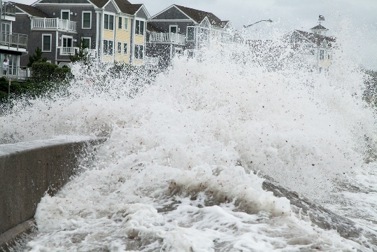
Fourth Station- We deny our responsibility.
Island states and coastal regions
Experience erosion and land loss
sea level rise and flooding
threatening vulnerable people and habitats.
Refrain

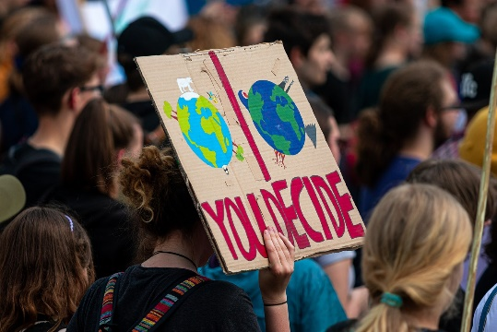
Fifth Station – We are judged by environmental activists.
Our ignorance and hardness of heart
Our lack of effort and participation
Our laziness and love of luxury
Speak against us.
Refrain

Sixth Station – We are crippled by finance systems
Which forget ethical investment
Which ignore environmental matters
of funding and resources
in the pursuit of fast living and profit.
Refrain

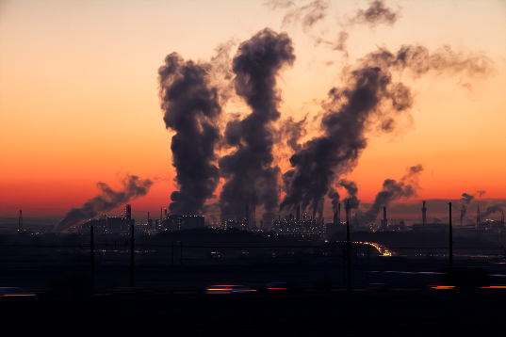
Seventh Station – We carry the mistakes
Of earlier generations and the use of fossil fuels
Of denial and ignorance
Of stubborn hearts and minds
And negligence and lack of vision.
Refrain

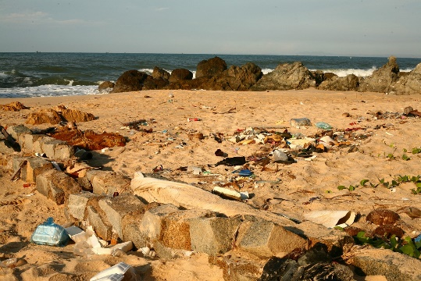
Eighth Station – We continue to pollute
Our rivers with industrial waste
The oceans with plastic waste and acidic solutions
The land with chemical fertilizers
And the web of life which sustains us.
Refrain

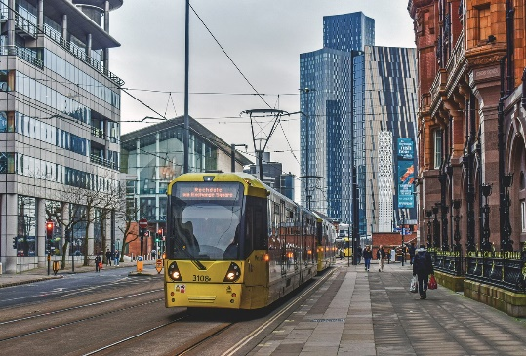
Ninth Station – We continue to degrade
The ecosystems which support us
And the world around us.
Our environment and landscapes
Our streets and cities.
Refrain

Tenth Station – We are supported
By educators and scientists
As they reveal the wonders of creation
By environmental campaigners
As they raise awareness of our need to protect the earth.
Refrain

Repeat the refrain
Amen.

Diocese of Leeds Environmental Worship Group - March 2023

