## For further assistance or information, please contact;

**childrenyouth@leeds.anglican.org**

**Children, Young People and Families Team**

Church House

17-19 York Place

Leeds

LS1 2EX

**Tel:** 0113 3530 238

**Website**

[www.leeds.anglican.org/children-youth](http://www.leeds.anglican.org/children-youth)

# Responding to Tragedy with

**Young People**

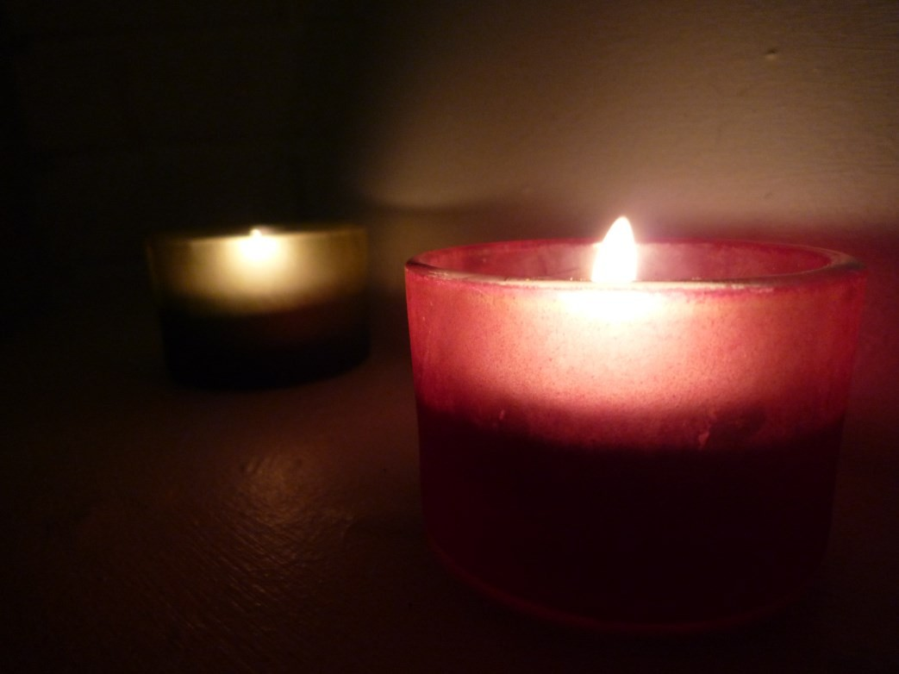

Based on a framework written by Danielle Dowd, Diocesan Youth Missioner for the Diocese of Missouri

## Some verses which may be appropriate for use in reflection and ritual following tragedy

**A frame-work for discussing tragedy with young people**

*Following the shooting of Mike Brown in Ferguson, Missouri, Danielle Dowd (the Diocesan Youth Missioner) put together a framework to help local churches open up discussions with young people. This has been adapted so that it could be used following other tragedies, from sudden death to global disaster.*

*There is a great service which most adults can offer to young people in helping them express emotions and acting as a sensitive listening ear. However, some young people may need greater specific professional help which you cannot offer. Be aware of what and where trained professional counselling services may be accessed and be ready to support young people in referral.*

### Psalm 23

**Isaiah 25:6-8**

**Isaiah 43:1-2**

**Matthew 5:1-10**

**Revelation 21:1,3-4**

**Step 4: Follow up**

This is not a one-off discussion. When we are talking about intersecting issues of violence, tragedy, race, and privilege; it is a lifelong, ongoing conversation. If certain personal things were brought up during discussion, commit those details to memory and follow up sensitively and appropriately. Offer time one on one (in a public space) with any young people who seem particularly affected or refer them to counselling resources if necessary.

## Introduction

We are rarely prepared for tragedy when it strikes. It comes unexpectedly through personal tragedy, through unimagined outrage or accident affecting the community, through war, terrorism or natural disaster which causes national or global shock.

Tragedy, on whatever scale, brings forth all sorts of emotions and questions and young people need a safe space where they can articulate their emotions, fear and questions. Yet in all this we can be consoled with the knowledge that our God is no stranger to heartbreak. Jesus enters into our messes. Jesus is present with us in our grief. And in this way, Jesus models for us the ministry of presence. Jesus shows us that to serve, the most important step is the first step.

### Framework steps:

1. Show up
2. Create a safe space
3. Provide appropriate outlets for emotion
4. Follow up

We may feel intimidated at the thought of having discussions with young people about tragedy. We may feel inadequate to lead them. But our young people need a safe space to tell their stories and process their feelings. They need us to come forth as servant leaders - leaders who are ready to sit with them, cry with them, to struggle alongside them, to listen to them. Many of the questions that come along with these discussions do not have easy answers but we need to enter into them anyway.

## Step 1: Show Up

This is the hardest and most important step. Show up. These conversations are difficult but we absolutely need to have them. Your ministry of presence is vital in these difficult times. In times of tragedy, people, especially young people, look to their leadership for how to respond. You are part of their faith community. You have made promises together, in baptisms. You have eaten at the Lord’s Table together. You have worshipped alongside each other. Because you have been present already in their lives in those ways, you are now called to continue your ministry of presence by giving young people an opportunity to wrestle with these difficult questions and emotions.

**Prayer** – After time to quietly reflect in the different mediums, come back together for a time of prayer or reflection such as:

* Create a litany using the petitions written in one of the ritual stations
* Place a candle in the center of the room, hold hands, and recite a prayer of healing together
* Place a cross centrally in the room and invite the young people individually to place a stone in front of it as a way of bringing the situation to Jesus
* Pass a cross or other object from person to person. Whoever is holding it either prays out loud or keeps a time of silence before passing it to the next person. Conclude together with The Lord’s Prayer

**Distribution of Resources** – When you have finished your prayer together, re affirm to the young people that you are there for them if they have any questions in the coming weeks and months. Distribute the Bible verses or any poem or other resource which you feel might be helpful for them in the coming days.

**Ritual and Reflection** – You may want to have different “stations” around the room where young people can process their thoughts and feelings in silence. These might include:

* an art station with finger paints, newspaper articles, paper, scissors, glue
* a meditative station with a single candle lit with encouragement to breathe deeply, perhaps using the Jesus prayer
* a finger labyrinth
* a prayer wall (a large sheet of paper with various markers) where they can write or draw prayers
* Bible verses about God entering into our sorrow with us written on pieces of card (see attached resource)

Give time for the young people to go from station to station as they wish. You may want to play some quiet instrumental music during this time.

## Step 2: Create a Safe Space

Invite your young people into a sacred time together specifically for these issues. Tell them that you are going to talk about the tragedy. Be aware of the physical space you choose to do this in. You will want the space to be comforting and inviting. Ideally, the space should be private (while keeping in mind safeguarding guidelines) and quiet, comfortable to sit together in a relaxed way without prying eyes*.

Maybe there are comfortable couches to sit on. If bring several big pillows and blankets and invite the young people to curl up on the floor in a circle. Bring simple snacks and drinks to share.

*\*remember that there should always be a minimum of 2 adult leaders with any group of young people.*

 

## Step 3: Provide Appropriate Outlets for Emotion

Consider the following as you prepare for the session:

**Information** – Give a brief synopsis of the known facts in the situation. Think about how you might explain the situation before-hand so that you may be intentional with your language, keeping in mind your context. Give a list of guidelines that you agree on for talking about difficult subjects. For example, you may want to state something like, “This is a safe place. Everyone has the right to have their feelings heard here.”

**Questions** – Open up time for questions. In this case, there are a lot of un-answered ones. Come prepared to answer questions with the most current, accurate information you have available. Expect frustration from teens when there are not clear or easy answers. Affirm their feelings by saying things like, “I can hear that you’re frustrated. I’m frustrated too.” Then listen.

**Discussion and Truth Telling** – Ask the young people how they feel about what happened. How does this relate to them, personally? What sorts of other, related, issues does this tragedy bring up for them? Affirm their feelings by reflecting them back to them. After you ask a question, do not be afraid to sit in silence for a while. Allow them to have the time to formulate their ideas and verbalize them. Do not feel the need to fill the silence. Depending on the context and personality of your group, some groups may talk a lot while other groups might not talk at all. Give them the time and space either way.