



**Bishop of Wakefield**

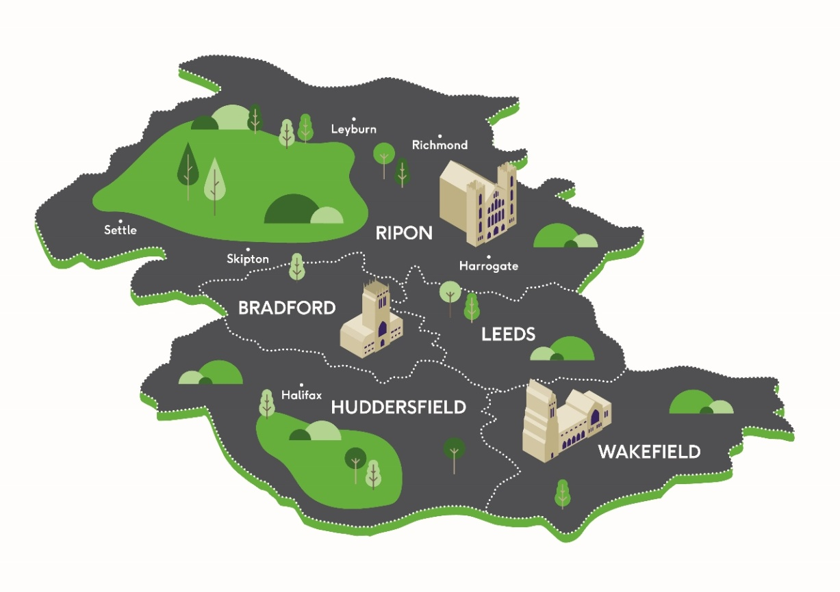

*This role description has been prepared on the basis of the requirements for the Bishop of Wakefield identified by the Bishop of Leeds and with the consent of the Board and Diocesan Synod of the Diocese of Leeds. As with any role description, it will need to be kept under review. If there are any particular concerns after six months, the Bishop may wish to raise these with the Diocesan Bishop. The Bishop will also wish to ensure that at his/her first Ministerial Development Review with the Diocesan Bishop this document is discussed and amended as appropriate.*

*This document should not be considered in isolation, but in the context of the vows and duties undertaken at the ordination and consecration as a bishop and also the Canons of the Church of England.*

*The Bishop will also have received various briefing documents to support his or her nomination and appointment.*

**Purpose of the Role**

To share with the Bishop of Leeds in the episcopal oversight and leadership of the Diocese of Leeds, working with him and fellow bishops in continuing to shape the diocese, to oversee and lead ministry and mission in the Wakefield Episcopal Area in close collaboration with the Archdeacon of Pontefract, and offering strategic support to the Bishop of Leeds across the diocese.

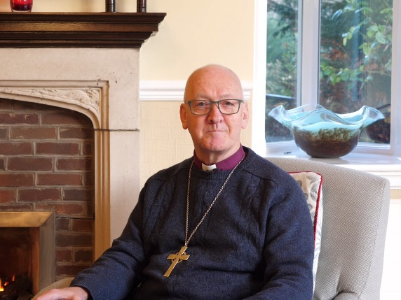

Hollin House,   
Weetwood Avenue,   
Leeds LS16 5NG

0113 284 4300

[bishop.nick@leeds.anglican.org](mailto:bishop.nick@leeds.anglican.org) The Rt Revd Nick Baines, the Bishop of Leeds

The Bishop of Wakefield will join the team of five Suffragan (Area) Bishops in the still young Diocese of Leeds under the leadership of the diocesan Bishop of Leeds. Each Episcopal Area is co-terminus with an Archdeaconry. Uniquely in the Church of England, the diocese has three cathedrals.

The responsibilities of each bishop are designated according to the Instrument of Delegation issued by the Bishop of Leeds in January 2017 and amended subsequently.

At the creation of the diocese at Easter 2014 the vision articulated was: *to be a vibrant diocese, equipping confident clergy to enable confident Christians to live and tell the good news of Jesus Christ in West Yorkshire and the Dales.* In time this dynamic became focused as: *Confident Christians. Growing Churches. Transforming Communities.* Later in 2016, as the initial transition phase drew to its conclusion and we were establishing our visual identity (branding, etc.), we re-shaped this in order to use terms that make sense to those outside the church: *Loving. Living. Learning.* We love God and neighbour – and the world/communities we are called to serve; we are incarnational, committed to the world as it is, but drawn by a vision of how it could be and working for the flourishing of individuals and communities; we have the humility to know our failure and our need to learn. This triplet is the lens through which we see our ministry and mission.

The bishops are the key leaders in driving the mission of the church in their episcopal area and, together, across this large and very diverse diocese. The bishops meet together monthly for a Six Bishops Meeting and, again, monthly as part of the Bishop’s Staff Meeting. Each area bishop convenes a monthly Area Staff Meeting which feeds into the Bishop’s Staff Meeting.

The bishop, based at Thornes Park, will work with the diocesan bishop and other colleagues to build an effective episcopal team, a strong and confident Bishop's Staff, and a purposeful Area team in order to lead the mission of the diocese, make good appointments to parishes, and lead ministry and mission within the Episcopal Area in accordance with the diocesan vision. This will include clergy MDRs, pastoral reorganisations, appointments of clergy, and so on.

The bishop will take on one or more portfolio diocesan leadership responsibilities, and, working with the Diocesan Director of Vocations, will be the sponsoring bishop for the Wakefield Episcopal Area.

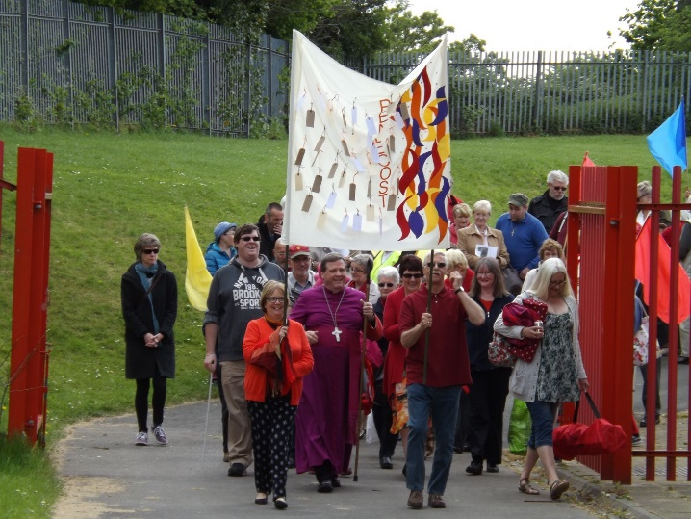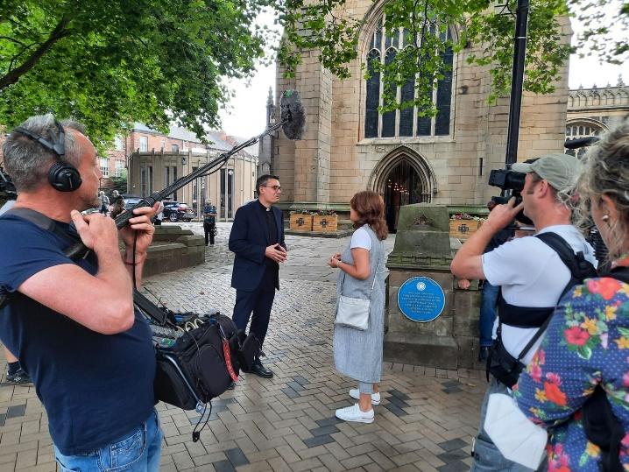

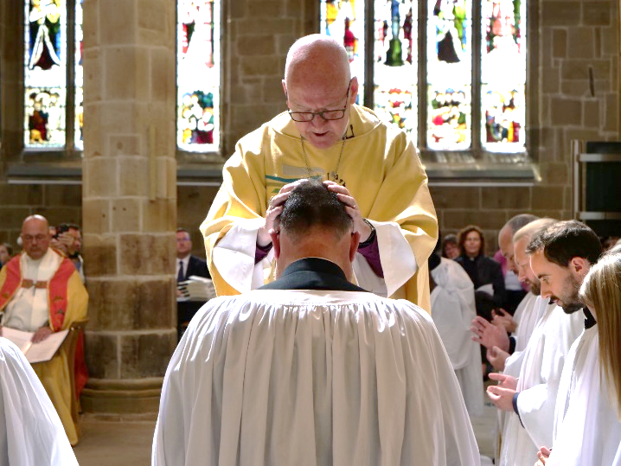

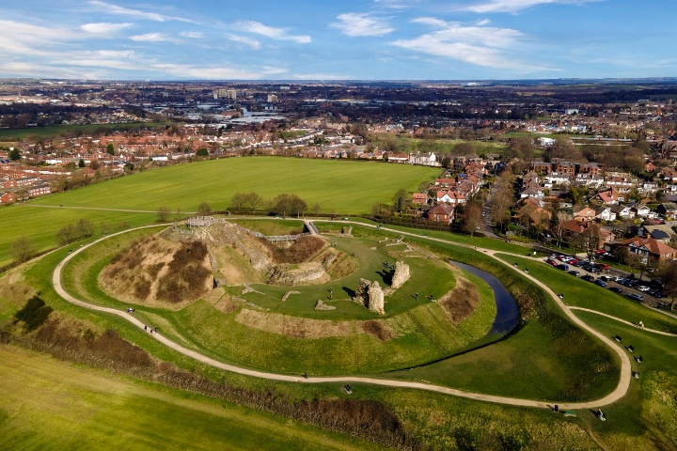**The Wakefield Episcopal Area**

The Wakefield Episcopal Area is coterminous with the Archdeaconry of Pontefract, which comprises three Deaneries: Wakefield, Pontefract, and Barnsley. In civic terms, it covers the Metropolitan District of Wakefield (population 345,000) which was formed in 1974 and is made up of Wakefield and the Five Towns (Pontefract, Castleford, Knottingley, Featherstone and Normanton) - and a significant part of Barnsley Borough (population 245,000) in South Yorkshire.

At the start of the 19th century Wakefield was a wealthy market town and inland port trading in wool and grain. On the outskirts of the town, coal had been dug since the 15th century. During the 19th century more mines were sunk so that there were 46 small mines in Wakefield and the surrounding area by 1869. The National Coal Board eventually became Wakefield's largest employer and the first national trade union for miners was established in 1842. In 1984, the Yorkshire area had a total of 56 collieries. The last deep coal mine was Kellingley Colliery which closed in 2015, signalling the end of deep coal mining not only in Yorkshire, but in Britain as a whole. The scars of this run deep.

The Episcopal Area has two prisons: HMP New Hall for women, and HMP Wakefield, a Category A men's prison which has been nicknamed the "Monster Mansion" due to the large number of high-profile, high-risk sex offenders and murderers held there.

The district is also the birthplace of world-renowned sculptors Henry Moore and Barbara Hepworth and is home to a thriving artist community, including the multi-award winning venues of The Yorkshire Sculpture Park and The Hepworth Wakefield.

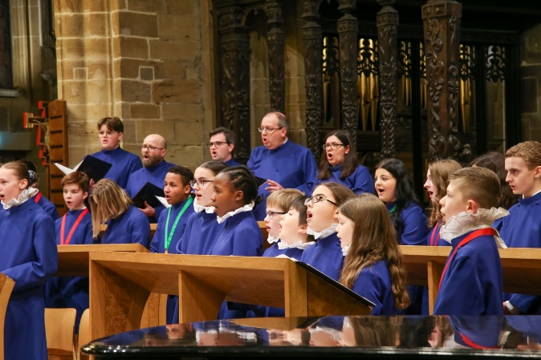

In demographic terms, the city of Wakefield saw immigration from the Indian subcontinent in the 1960s. Today there are seven mosques and Muslims constitute 3.2% of the local population in the 2021 census. Wakefield has an Initial Accommodation Centre for the north of England for asylum seekers. A very active City of Sanctuary group works to support them with help, clothing, and friendship. The city has at times been the centre of unwelcome attention from far-right groups and a good understanding of these issues is essential for anyone ministering here.

Helping churches to find new ways of fulfilling their mission will be a key priority in the next few years, while at the same time we face the realities of numerical decline and the need for pastoral revitalization and the likely closure of some of our churches. It is crucial that this work is done in the context of seeking to build up the church and encourage the growth of God’s kingdom, with an emphasis on revitalization and renewal, not retrenchment and managed decline.

In relation to encouraging growth, Wakefield was part of a successful SDF bid, which will see an expansion of its mission to teenagers and young adults in the town. We are committed to finding new ways to encourage effective co-operation in mission to a new generation, including making the most of our connections with around 26 primary and 3 secondary church schools in the episcopal area.

Overall, the churches in the Episcopal Area show some outstanding examples of missional engagement with their local communities, from urban estates to suburban and rural contexts – but right now people are feeling exhausted in the long tail of the pandemic. They need encouragement and a good deal of wise pastoral care to enable them to lift their eyes and look ahead with renewed confidence – and they also need a bishop who can walk alongside them and offer strategic wisdom.

There are 63 benefices and 110 parishes in the area, and 86 stipendiary clergy in post, including 59 incumbents and 15 SSM clergy. Total Usual Sunday Attendance before the pandemic was around 5,300, of which about 580 were children. Most of the area’s churches are small or medium-sized, with only two of large size. Clergy are dedicated and hard-working and face significant challenges in an area where attendance in the Church of England has traditionally been very low – largely for historical reasons, including the growth of non-conformist denominations during the Industrial Revolution.  A large majority of our parishes have embraced “Leading Your Church into Growth” (LYCiG) as a toolkit to assist with enabling spiritual and numerical growth, and this has met with some success.  The coronavirus pandemic had a major impact on church life here as everywhere, and many parishes – though not all – have responded creatively with new forms of worship and imaginative pastoral care and community engagement.

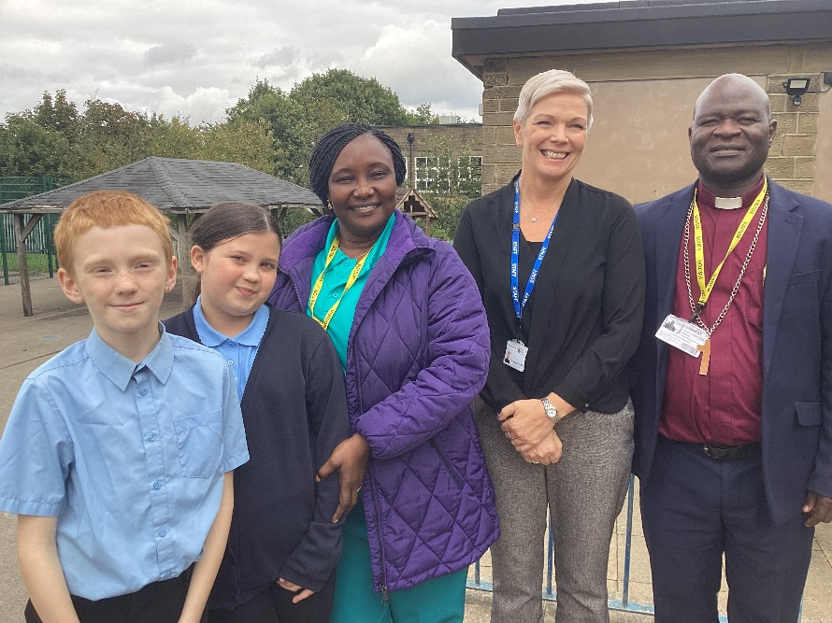

**The Diocese of Leeds**

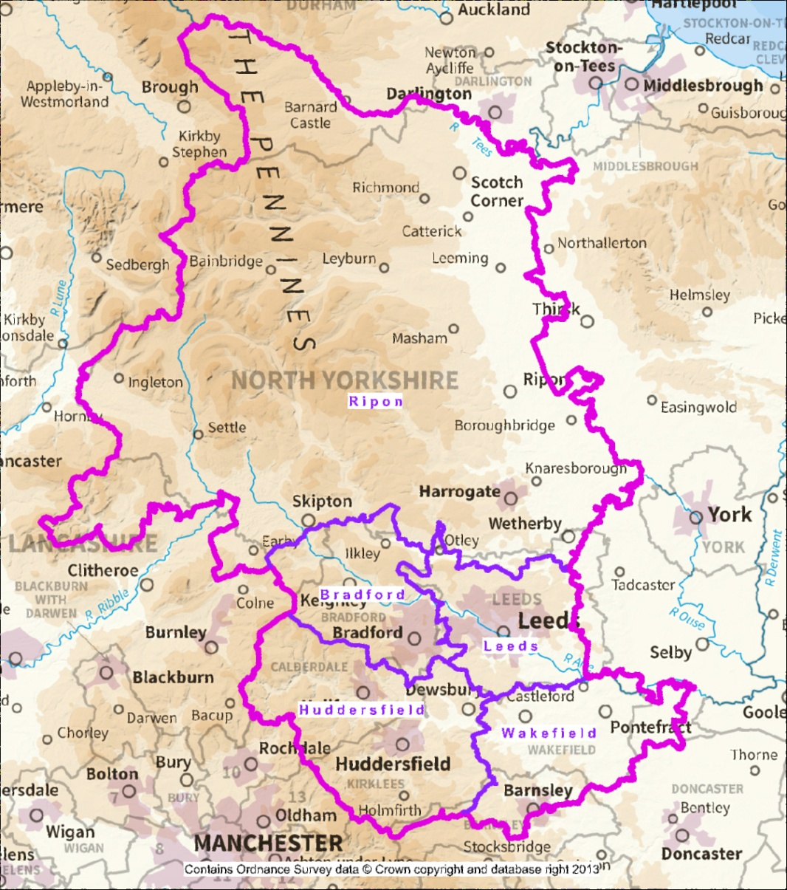

**The Diocese of Leeds**

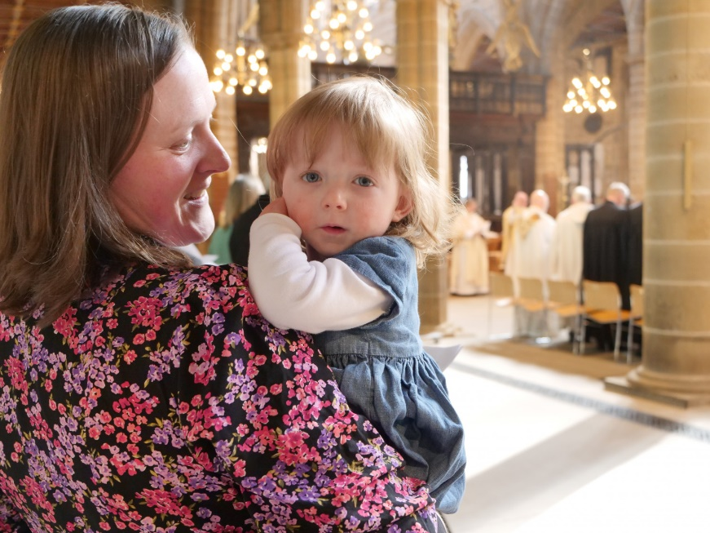The Diocese of Leeds covers a region whose economy is greater than that of Wales.

The diocese comprises five Episcopal Areas, each coterminous with an Archdeaconry. This is now one of the largest dioceses in England and its creation is unprecedented in the history of the Church of England. It covers an area of around 2,425 square miles, housing a population of around 2,642,400.

The three historic dioceses (Bradford, Ripon & Leeds, and Wakefield) were created in the nineteenth and early twentieth centuries to cater for massive population changes brought about by industrialisation and, later, mass immigration. The diocese comprises major cities (Bradford, Leeds, Wakefield), large industrial and post-industrial towns (Halifax, Huddersfield, Dewsbury, Barnsley), market towns (Harrogate, Skipton, Ripon, Richmond and Wetherby), and deeply rural areas (the Yorkshire Dales). All of life is here, along with all the richness, diversity and complexities of a changing world. The diocese recently received £734k in funding from the Racial Justice Unit to support exciting, forward-looking work within communities of every ethnic background, including a significant tranche of newly arrived people from Hong Kong.

The diocese is served by major motorways (M1, A1M, M62) and major trunk roads (such as the A650, A59) and has good road and rail networks. Leeds-Bradford Airport is in easy reach and Manchester Airport is only an hour away.

The five episcopal areas are: Bradford, Huddersfield, Leeds, Ripon and Wakefield. These are served by five archdeacons: Bradford, Halifax, Leeds, Pontefract, Richmond & Craven). 339 stipendiary clergy, 82 self-supporting clergy and 447 clergy with PTO minister along with 354 Readers, 85 lay pastoral ministers and 41 chaplains in 598 churches with 237 church schools.

The diocese is unique in having three cathedrals: Bradford, Ripon and Wakefield. There are Minsters in Dewsbury, Halifax and Leeds. Creating new ways of being and working – there was no template – have offered some great riches. Each cathedral serves the diocese (not its Episcopal Area), aligns its vision with the diocese and bishop, and attends to the distinctive nature of its particular context (interfaith Bradford, post-industrial Wakefield and rural Ripon). The deans meet regularly; they also meet with the diocesan bishop and hold an annual overnight residential meeting. The deans are essential members of the Bishop’s Staff Meeting.

The diocese has strong inherited partnership links with Sudan, Sri Lanka, Tanzania (Mara, Tarime, Rorya), USA (Southwestern Virginia), Sweden (Skara), Germany (Hannover and the Kirchenkreis Erfurt) and Pakistan (Faisalabad). A review has recently taken place and there might be changes to our links in 2024-25, including a potential new link with Hong Kong.

**Vision and Strategy**

The Diocese of Leeds has a vision for growing confident Christians who help grow churches which help transform communities. We want to be faithful to our calling to be good news, to live and tell the Gospel, and serve with purpose and commitment the communities that comprise our parishes and institutions. This vision – *Confident Christians: Growing Churches: Transforming Communities* – has formed the heart of our strategic direction since our creation ten years ago. Over the last two years we have been working on developing a framework for delivering this vision – one which meets the challenges of these times. In doing so we have been inspired by the example of Barnabas in the very early church. The resulting overarching strategic framework is designed to enable the diocese intentionally to support the missional needs of parishes, bringing a focus on revitalisation, growth and sustainability. *Barnabas*, which is funded by the national church, enables us to respond to the missional and financial challenges which the diocese faces over the coming decade.

*Barnabas*, then, is rooted in and promotes confidence in God’s unfailing love for us and the church. As confident Christians, we want to be:

* **confident in our mission**: supporting parishes to be confident in their church buildings, their finances and resources of time.
* **confident in our future**: ensuring that our levels of clergy deployment are fit for the future, and thus enabling to make deployment decisions in a mission-led way that gives clergy and parishes confidence that the diocese is committed to their thriving.
* **confident in our leadership**: offering significant and specific support around leadership and mentoring, both for clergy in their ministry and parish teams as they shape pastoral care and mission into the future.
* **confident in our witness**: encouraging support for all to be confident in living and telling the good news of Jesus in a rapidly changing world.

This is a vibrant and earthy diocese, pregnant with opportunity and up for the challenges before us.

**Challenges and Priorities of the Role**

The bishop will need to be resilient, confident in their experience, highly emotionally intelligent, flexible and adventurous in helping build new relationships, new structures and new ways of shaping the church and its mission.

The bishop's primary responsibility, exercised alongside the Archdeacon and Area Deans, is to know their parishes and clergy, to grasp nettles where challenge or support can lead to change, and to provide clarity of leadership and communication in encouraging evangelism, catechesis and service.

The Wakefield Episcopal Area requires a bishop who, on behalf of and in partnership with the Bishop of Leeds, can inspire, lead, serve and reach out in the name of Jesus Christ. The bishop must have the potential, based on proven experience, to lead inspiring worship, teach the faith to a wide variety of people, drive evangelism, grow disciples, equip ministers and root all this in a prayerful and confident humility.

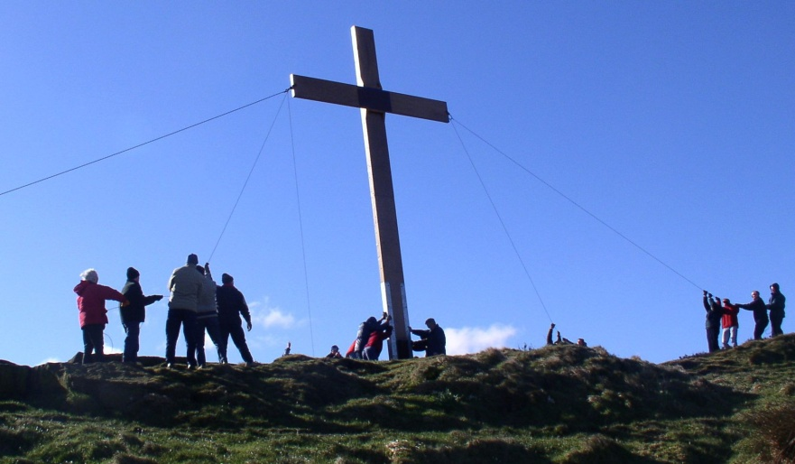The bishop will have the commitment, experience and capacity to help reimagine urban and suburban ministry in changing times. The bishop will be imaginative in helping re-shape the church’s mission in the wake of the pandemic, its losses and gains. The bishop will be comfortable engaging in the civic, business, university, cultural and social life of the towns and wider region, offering appropriate leadership.

The bishop will take on the pastoral care of clergy (including Ministerial Development Reviews), clergy appointments, and pastoral reorganizations. Bringing fresh vision and perspective to this task, the new bishop will have the ability to attend to detail without losing the bigger picture, and the potential to engage within and well beyond the church in raising the profile and offer of the Church of England in this region – for the sake of the kingdom of God and the common good of the people.

The bishop will have the potential to grow in confident engagement in the public square, be comfortable with social and other forms of media, be an effective communicator across media platforms, be able to encourage risk whilst supporting those who fail and derive energy from learning new skills. The bishop will see challenge as a positive opportunity.

The bishop will be able to support and implement the vision and strategy identified by the bishops in conjunction with the Diocesan Board and the Diocesan Synod. Together they will shape the diocese to enable parishes and institutions to create the spaces in which the people of our region can find that they have already been found by God. The bishop will be focused on enabling clergy and lay people to respond to the love of God as faithful worshipping communities and as increasingly confident disciples of Jesus Christ, encouraging joyful (and sometimes sacrificial) service in the power of the Holy Spirit.

This is clearly the bedrock of building the diocese, but it will be interwoven with a responsibility to offer appropriate leadership, at the Area level, with civic authorities, business leaders, community leaders/groups, leaders of other faith communities, ecumenical partners, local/regional arts and the local media where appropriate.

Each bishop carries responsibility for a pan-diocesan portfolio. However, this changes according to the gifts, gaps (in experience), potential, longevity, mix within the episcopal team, and needs of the diocese. It is expected that the next Bishop of Wakefield will take on a larger remit, but the specifics will be worked out according to who is appointed. At the very least, he/she will lead our ecumenical work, support the current Bishop of Bradford in interfaith work, be the sponsoring bishop in the episcopal area, lead/convene chaplaincy work, take responsibility for retired clergy across the diocese, chair the Tanzanian partnership link, make all clergy appointments and parochial reorganisations in the episcopal area, chair and lead the Area Bishop’s (monthly) Staff Meeting, and possibly chair a board once settled in. At that later stage, it is probable that the bishop will chair the new Ministerial Development Oversight Group, which will help cohere vocations and clergy training work.

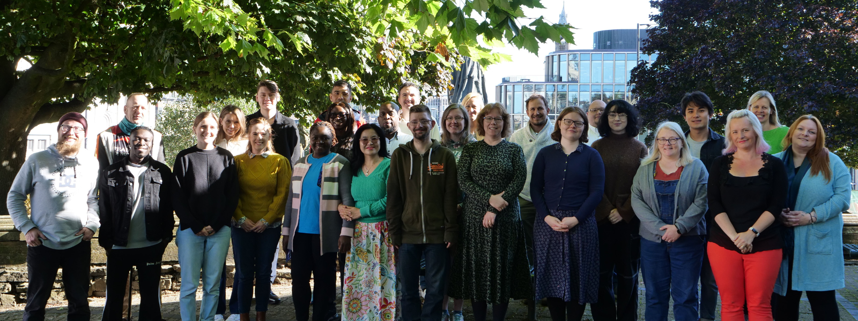

**Main Responsibilities of the Role**

Mindful of the themes of the Church of England’s emerging vision and strategy, namely *Simpler – Humbler – Bolder*, and cognizant of the Five Marks of Mission, the Bishop's main responsibilities can be summarised as follows:

* Act as episcopal colleague to the Diocesan Bishop and the other four Area Bishops; playing a full part on the diocesan senior staff; sharing in the leadership and development of the diocesebothwithin the Wakefield Episcopal Area and the wider diocese, shaping the Episcopal Area consistently with practice in the other Episcopal Areas.
* Exercise specific episcopal functions as are customary for a bishop, i.e. ordaining deacons and priests, appointing (according to the policy established by the Diocesan Bishop), licensing and instituting priests, conducting confirmations, pastoral visitations, and pastoral care and ministerial development of clergy.
* Work alongside colleagues in the development, adoption and local delivery of the diocesan strategy (*Barnabas: Encouraging Confidence*).

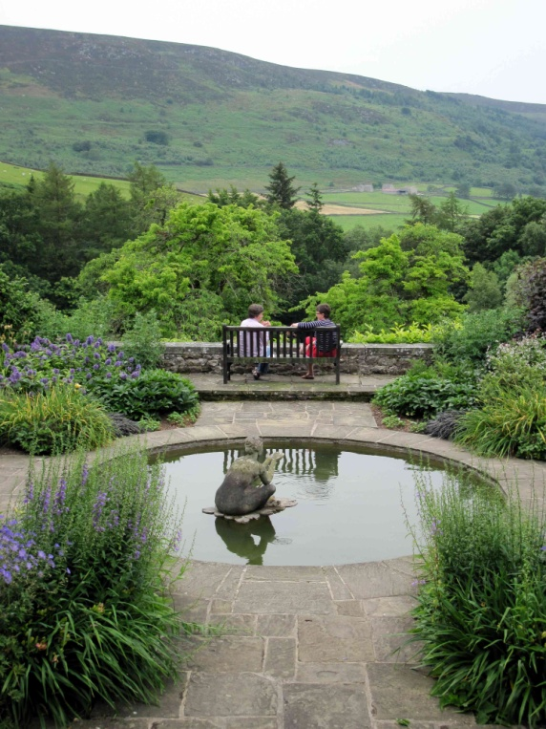

* Lead on promoting and embedding safeguarding into the culture of the episcopal area, working with the Diocesan Safeguarding Adviser and other senior staff to deal quickly and sensitively with any safeguarding concerns that come to light, whether current or historic.
* Challenge (as well as encourage) the Bishop of Leeds, offering robust advice and wise counsel for the good of the diocese and its people.
* Commit the highest priority to the monthly Bishops Meeting, the monthly Bishop's Staff Meeting, the monthly Episcopal Area Staff Meeting, the Diocesan Board (comprising the Bishop’s Council, Diocesan Board of Finance and the Diocesan Mission & Pastoral Committee) and the Diocesan Synod.
* Work closely with the Archdeacon of Pontefract in developing and leading strategy for growth in the Wakefield Episcopal Area, and working decisions/initiatives through diocesan structures – somewhat complex as these gradually migrate into new entities and channels.
* Excellent communication, pastoral and motivation skills are essential.
* Hold one or more diocesan portfolio responsibilities.
* Lead the strategic resource church programme in the Wakefield Episcopal Area.
* Pay attention to diocesan partnership links and chair the link with Tanzania.
* Encourage and facilitate lay ministry, mission and leadership.
* Establish strong relationships with the three cathedrals of the diocese.
* Help to relate the local church to the wider national church through membership of the College of Bishops, participation in its meetings, provincial episcopal consecrations, and partnership links as appropriate and agreed.
* Relate to civic and other bodies in the Episcopal Area, relating church to society and vice versa – in agreement with and as directed by the Bishop of Leeds.
* Engage effectively and realistically with ecumenical partners in our common mission across the diocese, but particularly in the Episcopal Area.
* Engage with leaders of other faith communities and bring them together for building the common good.
* Discharge all other duties as set out in canon law.

**Person Specification**

The Bishop of Wakefield will

* be a creative, ambitious, pastoral and godly person with a proven record of church growth, imaginative outreach and committed mission
* have experience of urban ministry and be able to translate this (not replicate it) in this diocese
* have some experience of other faiths and interfaith work at local and national level, demonstrating an understanding of modern Islam in Britain in general and West Yorkshire in particular
* demonstrate the capacity to hold the bigger missional picture whilst attending to detail effectively
* be able to work creatively with experienced and able colleagues, seeking to grow their ministry and not be threatened by it
* committed to the Five Guiding Principles and work effectively with the Bishop of Beverley in relation to parishes of the Society
* commit, along with other people and resources, to leading the church into growth, taking note of post-pandemic changes in the national leadership of the Church of England
* be expert in ‘working’ structures, able to translate this into the wider inspirational, strategic and visionary leadership required by a bishop
* be a good preacher and communicator, a strategic thinker and planner, able to establish administrative consistency, work to agreed timelines and provide clarity to colleagues, institutions and parishes
* have exercised effective parish ministry and leadership prior to taking on a senior role in the church
* be a proven team player, stimulated by the gifts and experience of others
* be disciplined and resilient in prayer (the daily office being a mainstay of spiritual life), committed to worshipping and praying regularly with colleagues
* be committed to his/her own spiritual, theological and professional development and growth
* be theologically able, reflective and articulate
* be a proven interlocutor with contemporary cultures, provoking creative and realistic thinking on worship, evangelism and mission
* have a proven ability to preach effectively, communicate widely outside the immediate church, and inspire respect in people
* be pastorally sensitive, compassionate and hospitable – especially to fellow clergy and lay leaders
* be able to hold confidences and inspire confidence
* be able to enthuse and motivate others, challenging where necessary and encouraging wherever possible
* be able to demonstrate a capacity for quick learning and robust critique of practice
* have a high capacity for work and have the energy, resilience and capacity for, and commitment to, the demands of the extensive travel which is an essential part of the role
* be able to see the urban through the lens of the rural, and the rural through the lens of the urban



**Timeline**

**Shortlisting** will take place on Friday 6 December 2024. **Interviews** will take place on Friday 24 January 2025.

**Additional information**

**Eligibility & pre-employment enquiries**

The nominated candidates will need to have the right to live and work in the United Kingdom. They will need to complete an Enhanced DBS check and a pre-appointment occupational health clearance.

**Safeguarding**

Experience of your competence in managing safeguarding forms a key part of the discernment process, as well as enquiries to reassure the appointing panel that you are not a safeguarding risk.

You will be asked to complete a confidential declaration and your bishop will provide a Clergy Current Status Letter (CCSL), prior to interview, having examined your blue file. Your referees are also asked to comment on your approach to managing safeguarding.

In the event of safeguarding concerns being raised, the Archbishops’ Secretary for Appointments will liaise with your bishop, the appointing bishop and the National Safeguarding Team (NST) for advice and direction on how to proceed. If any issues raised cannot be resolved within the timescales for the appointment process, you may be asked to withdraw.

**Induction and Development**

Each new area bishop (archdeacon and dean, too) is expected to take up to a month for induction. The shape and detail to this is provided by the Bishop of Leeds and the person then works it out according to their diary. Each new bishop meets the Bishop of Leeds for one-to-one meetings every couple of weeks for the first few months and, on request, at other times. In this diocese the bishops meet from 8am-3pm once a month for worship, Bible study/theology, mutual learning/development, and discussion. Each area bishop works closely with their archdeacon. The Bishop’s Staff Meeting meets from 8am-3pm once a month. We do two bishops’ residentials each year.

The nominated candidate will be required to attend safeguarding training, prior to consecration. There will also be a series of other induction meetings to help him/her begin the new role. In addition, there is training for bishops provided at national level.

**Consecration**

If the nominated candidate is not already in episcopal orders, their consecration is likely to take place in spring 2025 at York Minster, and they will be welcomed to the Diocese soon afterwards.

**Stipend, housing and office space**

The Bishop of Wakefield will live at Pontefract House, 181A Manygates Lane, Sandal, Wakefield, WF2 7DR. The Bishop of Wakefield’s Office is at Thornes Park Campus, Thornes Park, Wakefield, WF2 8QZ.

The stipend is set at the national level for a suffragan bishop of £42,750 per annum (as at April 2024). Holidays and expenses are paid according to the guidelines laid down by the Church Commissioners for suffragan bishops. The new bishop will be expected to comply with the regulations for common tenure and the associated terms of service. Full pension provision is made, and a car is provided from the Church Commissioners’ block grant funding where required. Full working expenses are paid from the block grant.