Let all things their Creator bless,
And worship Him in humbleness,
O praise Him! Alleluia!
Praise, praise the Father, praise the Son,
And praise the Spirit, Three in One
O praise Him, O praise Him!
Alleluia! Alleluia! Alleluia!

Prayer of commitment

We commit ourselves to care for the world God has given us; to care for all creatures; to cherish and provide for the pets and animals in our care; to protect any animals we find in distress.

Heavenly Father, giver of all life,
Fill our hearts with generosity and love
That we may fulfil what we have promised;
Bless, O Lord, these creatures,
And all who are involved in their care and protection.
May our awareness of their needs
Make us sensitive to the needs of every creatures for we ask this is the name of Jesus Christ our Lord. Amen

Blessing

May God the Father of our Lord Jesus Christ, who is the source of all goodness and growth, pour his blessing upon all things created, and upon you his children that you may use his gifts to his glory and the welfare of all creatures and all people; and the blessing of God almighty, the Father, the Son and the Holy Spirit be with you, and all who you love, today and always. Amen

Go in peace! Serving God and loving all creatures!
We go in peace, Serving Christ and loving all creatures.

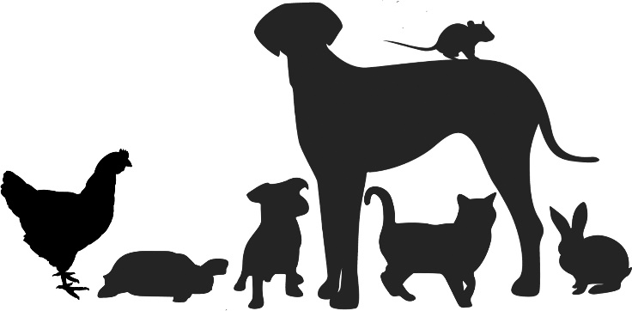
Blessing of Animals

Welcome and Introduction

Liturgy of Welcome from Psalm 148

All dogs and cats, large and small: Praise the Lord!
All rabbits, hamsters, gerbils and guinea pigs: Praise the Lord!
All goldfish and swimming creatures: Praise the Lord!
All robins, wrens, and singing birds: Praise the Lord!
All bats, squirrels, and badgers: Praise the Lord!
All horses, cows, and sheep: Praise the Lord!
All lizards, snakes and creeping things: Praise the Lord!
Every animal in the sky, the sea, and the forest: Praise the Lord!

Song- All things bright and beautiful
All things bright and beautiful,
All creatures great and small,
All things wise and wonderful,
The Lord God made them all.
Each little flower that opens,
Each little bird that sings,
He made their glowing colours,
He made their tiny wings.
All things bright ...
The cold wind in the winter,
The pleasant summer sun,
The ripe fruits in the garden,−
He made them every one:
All things bright ...
He gave us eyes to see them,
And lips that we might tell,
How great is God Almighty,
Who has made all things well.
All things bright ...

Saying sorry

Lord, for all the animals in the whole wide world, We thank you, God!
Lord, for all the fun and friendship we have with animals, We thank you, God!
Lord, for all the times we have hurt or neglected animals in our care, We are sorry.
Lord, for the ways that animals are not cared for properly in our society, We are sorry.
Lord, for all the times we have destroyed or failed to protect the homes of animals in the forests, oceans, or fields, We are sorry
We thank you Lord, for your full and free forgiveness. Thank you that you give us the chance to start again with clean slate. Help us to always be loving and attentive to the animals in our care. Amen

Animal Stories

Why do you love your pet?

An interview with a vet or pet shop owner can be included

Reading: Isaiah 6: 6-9

The wolf shall live with the lamb,
the leopard shall lie down with the kid,
the calf and the lion and the fatling together,
and a little child shall lead them.
The cow and the bear shall graze,
their young shall lie down together;
and the lion shall eat straw like the ox.
The nursing child shall play over the hole of the asp,
and the weaned child shall put its hand on the adder’s den.
They will not hurt or destroy
on all my holy mountain;
for the earth will be full of the knowledge of the Lord
as the waters cover the sea.

Talk

We pray for our pets
Please remain where you are for this part of the service- we will come round and pray for you and your pets! As you wait, you might like to thank God for your pet.
Prayers

Hymn: All creatures of our God and King

All creatures of our God and King,
Lift up your voice and with us sing,
Alleluia! Alleluia!
Thou burning sun with golden beam,
Thou silver moon with softer gleam!
O praise Him! O praise Him!
Alleluia! Alleluia! Alleluia!

Thou rushing wind that art so strong,
ye clouds that sail in heaven along,
O praise Him! Alleluia!
Thou rising morn, in praise rejoice,
ye lights of evening find a voice!
O praise Him, O praise Him!
Alleluia! Alleluia! Alleluia!

