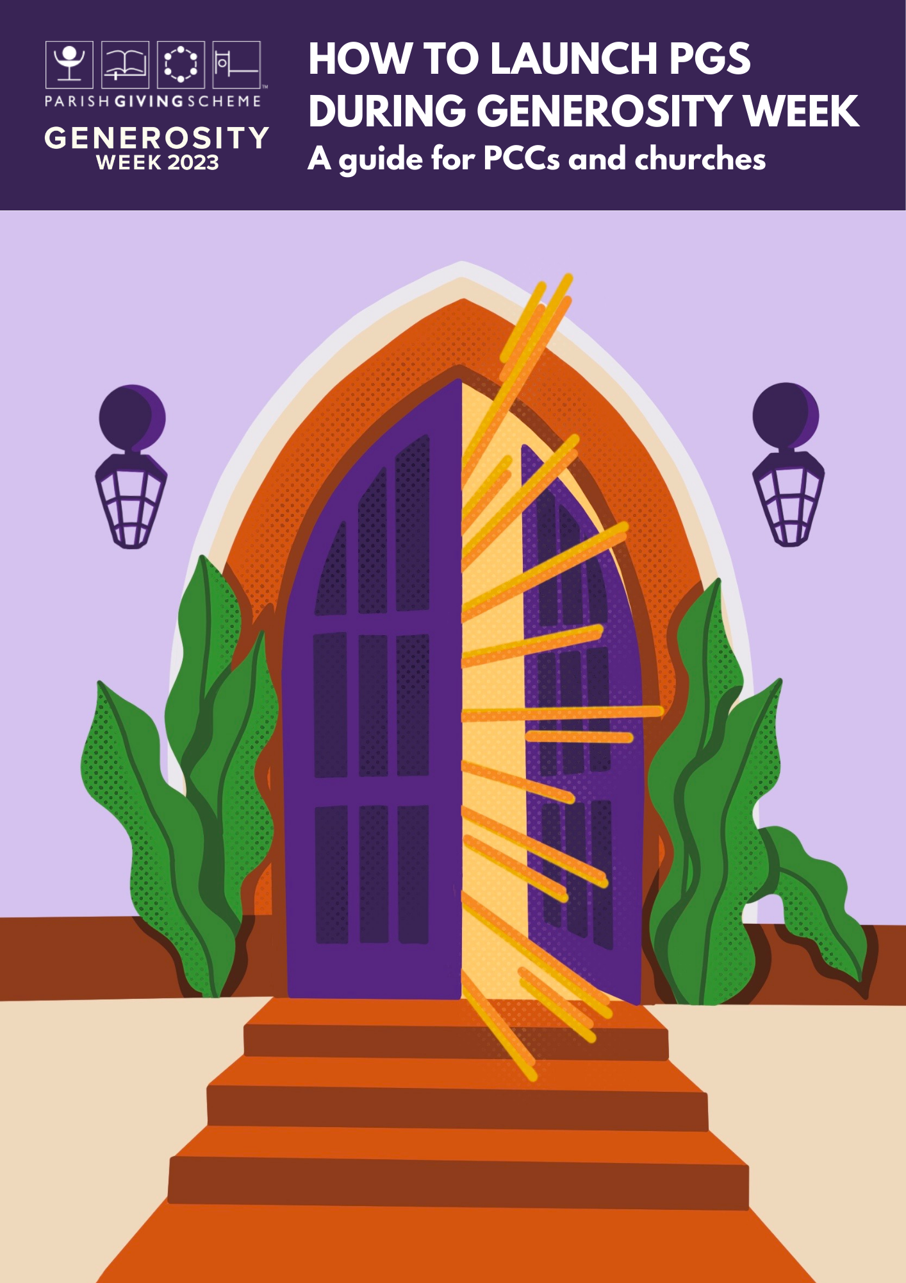

**Hint** Including themed worship, preaching, teaching and prayer in your Giving Programme will give a fuller and more meaningful context to the Parish Giving Scheme, as part of discipleship and faith.

The National Giving Team shares many great resources for Generosity Week, freely available online here: [https://www.churchofengland.org/resources/building-generous-church](https://eur02.safelinks.protection.outlook.com/?url=https%3A%2F%2Fwww.churchofengland.org%2Fresources%2Fbuilding-generous-church&data=05%7C01%7Cannie.rey%40churchofengland.org%7Cb5b0d470141a4205f79e08dac300fed2%7C95e2463b3ab047b49ac1587c77ee84f0%7C0%7C0%7C638036707939569364%7CUnknown%7CTWFpbGZsb3d8eyJWIjoiMC4wLjAwMDAiLCJQIjoiV2luMzIiLCJBTiI6Ik1haWwiLCJXVCI6Mn0%3D%7C1000%7C%7C%7C&sdata=fZcm66cuYmt%2FwvTKg%2BUevZ0ssXQMGzLJql93Qx3bBdQ%3D&reserved=0)

Your diocese Giving Advisor can also share with you the experiences of other churches, offer support and useful resources for planning and facilitating your Giving Programme.

**Hint** Include your PGS QR code on materials where you can, including leaflets, posters and orders of service. This makes it easy for someone to go straight to your church’s page on the PGS website, to begin their giving journey.

**Hint** PGS has created a range of materials about the Scheme that you can customise for your church, from leaflets to website buttons and posters.

All the digital files are free to use. You will find the full list of resources here, including a flyer and poster specifically for Generosity Week 2023: https://www.parishgiving.org.uk/pgs-digital-service/your-guides-and-resources/

**Hint** Why not play one of PGS’s colourful short animations as part of a presentation? Or stream it to your website? One shows how simple it is to give through PGS, and the other explains the benefits – and safety – of giving by Direct Debit.

The PGS team has prepared answers to some frequently asked questions (FAQs) which you may find helpful. You will find the animations and FAQs here: www.parishgiving.org.uk/pgs-digital-service/your-guides-and-resources/

PGS Registered Charity 1156606

Your Diocesan team is on hand to guide churches through the process of joining the Scheme and preparing for a successful launch.

Please contact:

Name:

Job title:

Email :

Tel no