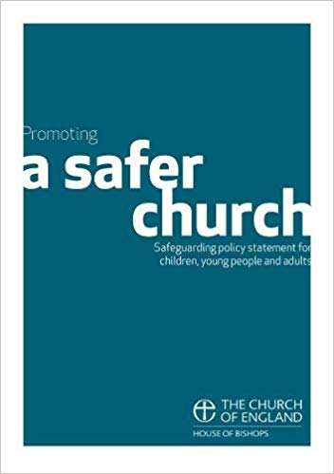
Safeguarding Policy Statement
Promoting a Safer Church,
House of Bishops, 2017

This Policy Statement on Safeguarding in the Church was adopted by

...................................................................................................................................................
(Parish/Benefice)

at a Parochial Church Council meeting held on .........................................................................

Each person who works within this church will agree to abide by these recommendations and the guidelines
established by this church. This church appoints ……………………….............................................. as the
Parish Safeguarding Officer.

The application of this policy will be reviewed each year and a report provided by the Parish Safeguarding Officer to the PCC.

Signed on behalf of the PCC by:
Name………………………………...........……………………………………........ Role…………………………………………………

Signature……………………………………….............................................. Date………………………………………………..

